Part 1: Water, Water Environments and Natural Processes

Section E:

COASTAL AND MARINE WATERS

Coastal and marine water systems
The largest surface waters are oceans, which are at the same time the largest geographic features on the surface of the Earth, covering approximately 70% of the planet's surface. As a result, oceans have a tremendous impact on the Earth, its climate, and its inhabitants.
Coastal waters are the area between the open ocean and the shore. Exemples include bays, estuaries, gulfs, sounds, straits, deltas, lagoons etc. These waters provide habitats for many different plants and animals. They are rich fising grounds and serve as nurseries or spawning grounds for many fish and shellfish. They offer year-round recreation opportunities for many people. They also provide us with some commercial products.

Types of coast
In the same way as riverbanks, also the coasts of lakes, lagoons and seas move and change according to the movement of water currents and sediment transportation. Sediments are brought to the coast by rivers or are created on the coast due to coastal erosion. The changes of the coast are especially visible and can be problematic if the coast is sandy or consists of other non-consolidated material that can be easily moved.
There are several types of the coast. Cliff is a common type of coasts with abrasive erosion. They absorb the energy of huge destructive waves that could easily knock down a house. Sand dunes is a common type of the coast with accumulation of sand. Sand dunes protect low lying land from flooding when there are high tides and storms.
Very specific type of coast are estuaries. Estuary is where the mouth of a river meets the sea. It is a specific environment, because at the edges of the river, the land is covered and uncovered by the water, over and over again as the tides go in and out. The water in estuaries is a mixture of fresh and salt (sea) water, and its salinity usually varies with its distance from the open ocean.
Estuaries seem to have been relatively rare features during most of Earth’s history. As the last Ice Age withdrew and sea level rose, estuaries were formed along the continental shelf. There are five basic formations:
- Drowned river valley - the classic estuary, wider than deep and triangular in shape. It consists of marshes, mudflats, and tidal creeks. These are coastal plain estuaries.
- Deltaic - the most changeable, fluvial depositions, river discharge great, very subject to waves, tides, longshore currents, storm damage, sediment lay down (Red River Delta, Mekong River Delta).
- Bar-built - the most dynamic, a series of bars or islands created from offshore deposition of sand, washed down by rivers or from deep water, the sand walks up the continental shelf and stabilizes. Bar-built estuaries are usually laterally extended along shore and are long, narrow, and low. Examples are a sand spit or barrier island. The estuary exists on the leeward side. These can change quickly and are controlled by oceanic movements. Examples of bar-built estuaries are many islands along the east coast of Vietnam.
- Tectonic - estuaries formed when the Earth’s crust shifts suddenly as in an earthquake, volcanic eruption, or a tsunami. Tectonic estuaries have no definite shape.
- Fjord-drowned glacial valley - usually in arctic and polar regions, u-shaped, deeper than wide, small river discharge, large tidal volume, important to shipping (located in Alaska, New Zealand, Norway…);
Estuaries are defined as partially enclosed bodies of marine water fed by freshwater sources, such as where a river flows into a bay. Their water is mixed with sea water. Salinity can vary with distance from the inflow of fresh water and other factors. Estuaries form a fragile boundary between marine and freshwater habitats.
This is ussually a very productive part of a coast with lots of plants and birds. Estuaries provide food for millions of birds. One cubic metre of mud from an estuary contains the same amount of food energy as 12 chocolate bars. Plants and animals can be found from the fresh water of the river and the salty water of the sea. Because the water is ussually shallow, sunlight reaches the bottom. This means that plants can easilly grow. These conditions make estuaries ideal breeding places for fish. Many fish caught at the sea began their life in the shallow waters of esturaies. They are very valuable as breeding grounds for thousands of species of aquatic animals and plants, as recreational areas, as shipping lanes, and as commercial fisheries.

Coastal water systems as natural resources

The coastal and marine water systems represent important natural resources. Over 90 percent of the world’s living biomass is contained in the oceans. Many services of the coastal and marine water systems are explored and exploited. On the other hand, many serious threats to the sustainable development of these resources are visible.

The coastal and marine water systems are used in many ways. The sea is a medium of transportation for goods and persons. The offshore exploitation of gas, oil, sand and gravel takes place; the coastal and marine fisheries provide food.
Animals and plants are a major marine resource. Over 1 billion people receive their entire annual protein supply from the sea. Marine plants provide less than 1% of our food (compared to 80% from land plants). Some current uses for marine plants include being used in bakery and dairy products, meats, soft drinks, and industrial applications such as tire manufacturing (due to the colloidal and gelling compounds common in seaweed). In the future, marine plants may be a possible food source to feed an ever increasing world population.
The wetlands in the coastal areas are a tremendous resource. They provide the habitat for fish, shellfish, waterfowl, and mammals. Coastal estuaries and marshes are among the most productive areas in the world providing organic matter for the base of the food chain and the spawning grounds for fisheries. Three quarters of the coastal fishes including most of the commercial fish species, are born and nursed in the coastal wetlands. The coastal and marine ecosystems like mangroves, sea grasses and corals contain many resources varying from natural medical herbs to protection during typhoons.
Worldwide, about one billion persons, depend on fish, as their sole source for protein. There are signs that many of the world’s marine fisheries are in serious trouble: the increase of global marine fish catches (1970-1991) seem to exceed the estimated potential sustainable fish yield since the mid eighties of the last century (see also CCC III-2). Several observations are made: (1) The over-fishing is indicated by the increased catches of ever smaller seized fishes. (2) The way of fishing: dynamite and cyanide fishing is not only killing the commercial fishes but kills all fishes and many other marine species; (3) Human induced pollution and climate change are negatively impacting the health and the resilience of the coastal wetlands. Recent estimates indicate that about 3/4 of the coral ecosystems in the Indian Ocean are effected by “coral bleaching”, which leads to the dying of the total coral ecosystem and to the loss of its economic touristy resource base.

Functions of the coastal zone
Coastline, the area where land, air, and sea meet, is one of the most dynamic and ecologically important places of our planet. These areas have been influenced by changing sea levels over the past thousands of years as well as by the constant action of waves, winds, and tides. Perhaps the most profound influence in modern times has come at the hands of people through their ignorance of the importance of coastal wet areas. Recently we thought of any coastal areas that did not have a white sandy beach as a wasteland that needed draining, filling in, or some other modification that would render it suitable for our needs. We now understand that our label “wasteland” could not have been more inaccurate. Instead, it is one the most fertile, productive places on Earth, serving as a sanctuary and nursery for much of the life in the sea. Many species produce eggs and juvenile stages that require the lower salinity, the mud, or the grassy cover found in numerous coastal habitats, especially estuaries. We also now realize coastal areas’ importance as a storm buffer, absorbing the impact of wind and waves so that less damage is sustained inland where greater human populations reside. And finally, their importance as a biological filter has been realized. It is in this role, perhaps, that coastal areas are most important. Many pollutants people produce are naturalized in these vast expanses and even help feed the detrital mill so basic to the entire system. Coastal regions compose an array of features with a complex shoreline. Not all have the important functions described, but each has unique characteristics that make it an important habitat.

Lesson E1: COAST AND COASTAL WATERS

Main idea: Coastal waters are the area between the open ocean and the shore. Exemples include bays, estuaries, gulfs, sounds, and straits. These waters provide habitats for many different plants and animals. They are rich fising grounds and serves as nurseries or spawning grounds for many fish and shellfish. They offer year-round recreation opportunities for many people. They also provide us with some commercial products.

Goal: The student should be able to define coastal waters, as well as locate and label coastal waters on a map.

Concepts: → coast → coastal waters (coastal regions) → estuary, inlet, gulf, bay, strait…;

Introduction: Where the land meets the sea
Ask children to tell where the land meets the sea? Remind them that the Earth is only 30% coverd by land, the rest are seas and oceans.

Activity: By the sea
Materials: globe or world map, map of the province, »Post-it« slips of paper, marker;
- Have a discussion with students about sea, coast and coastal waters:
- Ask the students if they ever visited an ocean beach and went swimming. Tell them that if they have they have swum in coastal waters.
- Ask how many have eaten shrimp, oysters, clams, orothertypes of shellfish. Tell them that those shellfish probably began their Iife and/or spent a part of their life in coastal waters.
- Define coastal waters for the students and share the background information with them.
- Use a globe or world map to point out examples of these coastal waters around the world. For example, point out the Bay of Bengal (between India and Southeast Asia) , the Persian Gulf (in the Middle East), the Straits of Hormuz (at the south end of the Persian Gulf) o rthe Straits of Magelan (south end of South America), and the Mouths of the Amazon (South America) where there are extensive estuaries. Sounds are so small that you probably will not find one on a globe.

- Provide the students with the map of the province.
- Place your finger on the source of the river and trace it to the sea, explaining what an estuary is when you reach the sea.
- Point out examples of coastal waters and briefly explain what they are. Be sure to include the bay, gulf , strait, and sound. (Include the others if your students are curious about them.)

- Tell the students they are to locate and label the coastal waters with »Post-it« stickers on the map of a province. Together with students try to come up with correct definitions for the terms.

Activity: Coastal Waters
Materials: map of the province, Worksheet E1/1- Coastal waters, »Post-it« stickers;

- Review coastal waters terms and definitions:
Bay: a large estuarine system.
Estuary: the area where a river empties into an ocean; a bay influenced by the ocean tides, resulting in a mixture of salt water and fresh water.
Open sea: area of sea that is not closed in by land, opposite of coastal water;
Delta: a deposit of sand and soil, usually triangular, formed at the mouth of some rivers
Mangrove swamp: land having soils saturated for at least part of the year and supporting natural vegetation of tropical trees, which send roots down from their branches
Cove: a small bay
Inlet: strip of water extedning into the land from the sea, or between islands.
Harbor: a waterbody where wave action is reduced or dampened
Lagoon: as a wastewater treatment method, an animal waste treatment method which uses a deep pond to treat manure and other runoff from a livestock operation, may be aerobic or anaerobic (both use bacteria to break down wastes)
Gulf: a part of the ocean or sea extending into the land.
Sound: long, broad inlet of the ocean with its larger part roughly parallel to the coast.
Strait: a narrow passageway connecting two Iarge bodies of water.

Look at the picture of the coast (Workheet E1/1 – Coastal waters) and define coastal waters. On a separate sheet of paper write definitions for terms that describe coastal waters:

Locate each coastal waters’region.

Discuss the identifying characteristics that make it unique (shape, appearance…).
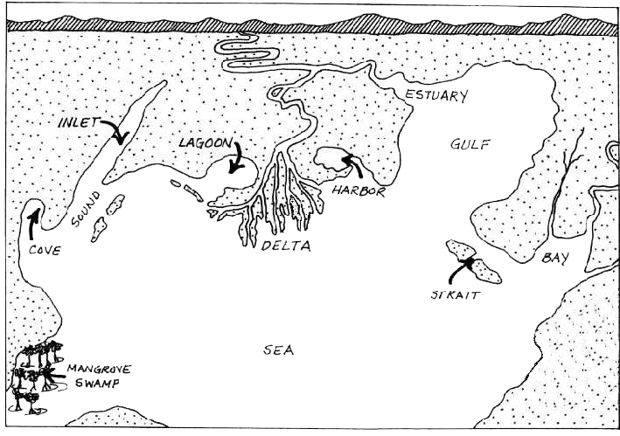

Have students identify coastal regions on a map of the province. Have students label each region using “Post-it” stickers.

Activity: Coastal region model
Materials: modeling clay (made by mixing 2 parts flour to 1 part salt with water and vegetable oil), plywood board, paint in at least two colors (blue for water and brown for land), various material to prepare the model as realistic as possible (small branches, wire, plasti plants etc.);

Creating a model of a coast:

Divide class into groups (determined by number of models being built and put together into one coast), or each class could contribute to a single model.

Use prepared modeling clay to mold a model that depicts various coastal habitats. The habitats are placed in one section of the plywood form so that it fits beside others creating an entire coastal region.

Areas under water may be painted blue while land features may be painted brown.

The finished product should reinforce the concepts of coastal habitat studies. Describe to other groups your coastal region and its characteristics.

Discussion: Coastal waters in my vicinity

Have students research the coastal waters in their vicinity. Have them research the plant and animal life of their habitat and report their findings to the class.
Worksheet E1/1: COASTAL WATERS

Directions: Look at the picture of the coast and define coastal waters. On a separate sheet of paper write definitions for all the following term that describe coastal waters: inlet, lagoon, estuary, gulf, bay, strait, harbor, sea, mangrowe swamp, delta, distributaries, cove, sound;
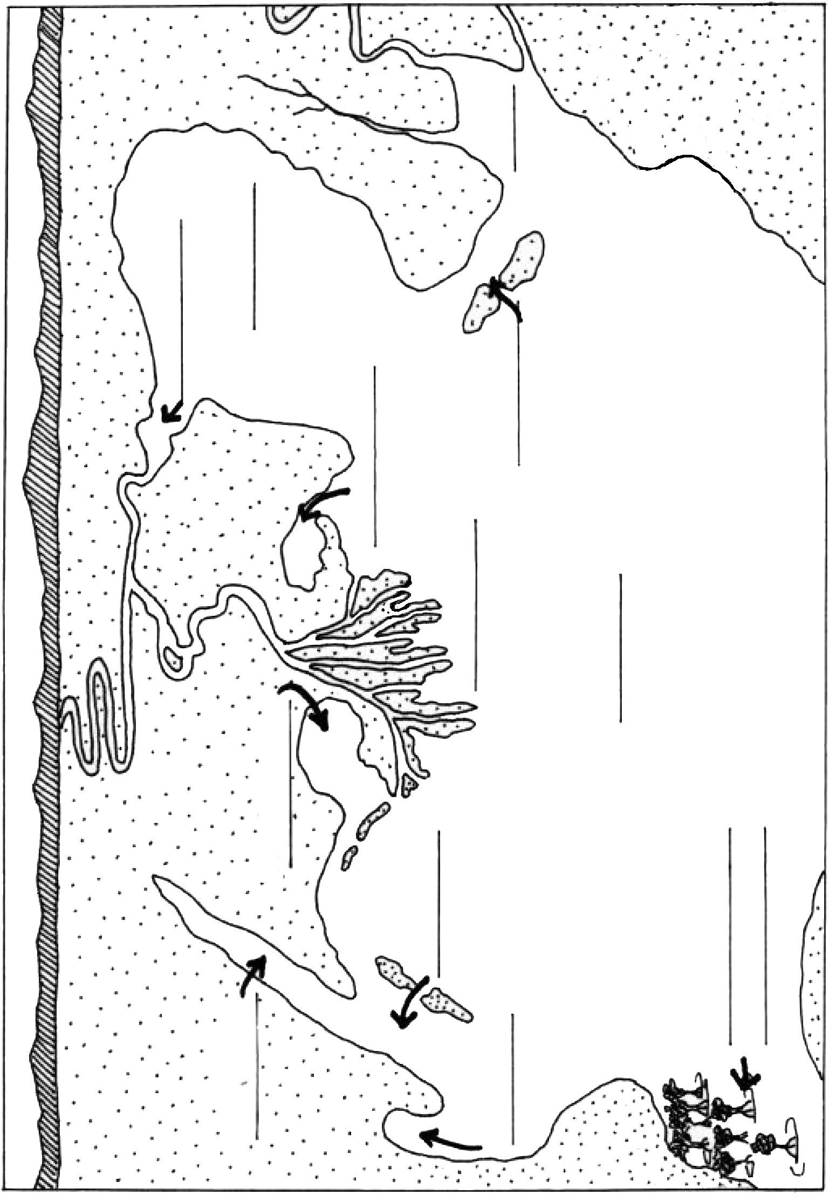

Lesson E2: ESTUARY

Main idea: Estuaries are the bodies of water found where rivers empty into the sea. The physical environment of an estuary includes intertidal emergent wetlands, seagrass meadows, soft bottoms, hard substrates, and aerial habitat. The mud in an estuary can be couple of meters thick! The mud is, for the most part, anaerobic and very rich in nutrients. The pulse of the tides, creating a daily or twice daily flushing, brings renewal and diversity of temperature, salinity, and dissolved oxygen. Limiting factors, such as elevation, tides, temperature, salinity, desiccation, and predation, mean that animals must be adaptable to live in the estuarine environment. Therefore, nowhere is the food web more apparent and fragile than in the estuary.
Estuaries were formed during the sea level rise period (after the last Ice Age) along the continental shelf. There are five basic formations: drowned river valley, fjord or drowned glacial valley, wide river deltas, bar-built estuary with lagoons (that builds long sandy islands along the shore), and tectonic estuaries. Their main characteristic is wide flat area afected by tides, so that broad coastal wetlands are formed.

Goal: To present students basic types of estuaries, explain them how they were formed, why they are important and what their most interesting features are.

Concepts: coastal waters → estuary → drowned river valley, wide river delta, bar-built estuary… → biodiversity (tides)

Introduction: River’s mouth
Ask students what is a river’s mouth. What type of river’s mouth they can point our. What are the characteristics of rivers mouth?

Activity: Formation of an estuary
Materials: modeling clay, petri dishes (10 to 15 cm) or plastic plates, food coloring, ice trays or paper cups, map of Vietnam;
- Explain students what are estuaries and how they were formed. Go through all five types of esturaies and point out those that are most common in Vietnam.
- Have students locate the different types of estuaries and particular the main deltas on a map of Vietnam. Discuss estuaries that students may have visited or seen.
- Explain students that they will demonstrate a sea level rise to demonstrate formation of estuaries.
  - Hand out clay and petri dishes and have students construct a coastline with raised areas indicated by the clay in various formations inside the dishes.
  - Give each student or partners, if they work in partners, three cubes of ice and let them place the ice on the clay in the dish. The teacher may want different students to create models that will form the different types of estuaries.
  - As the ice melts, they can see an island get covered or a ditch or valley fill in.
  - Have students look at the different models to see, if they can identify the types of estuaries formed. (It may be necessary to reform some models, if the water did not fill in where expected.)

Activity: Biodiversity of estuary
Materials: Worksheet E2/1 »Estuary«,map of the province;
- Explain students that they will explor various habitats in an estuary. Tell them that estuary is very much affected by tides. In a discussion explor:
  - What are tides? (Tides are the natural rise and fall of oceans caused by the moon’s gravitational pull. High tide is when the water comes up to the highest point on the shore. Low tide is when the water goes down to its lowest point. Most places have roughlytwo high tides and two low tides every 24 hours.)
  - What are the characteristics of environment that is affected by tides? (there are two types of environment: environment that is regularly - dayly affected by high tides, and areas that are infrequently – only during storms affected by high tides)
- The physical characteristics of life in estuaries determine habitats that all the creatures in such environments are adapted to. Distribute Worksheets E2/1 - Estuary to students and discuss the parts that are marked. Identify and discuss the smaller habitats found in this environment. Write down on marked lines the names of the identified parts.
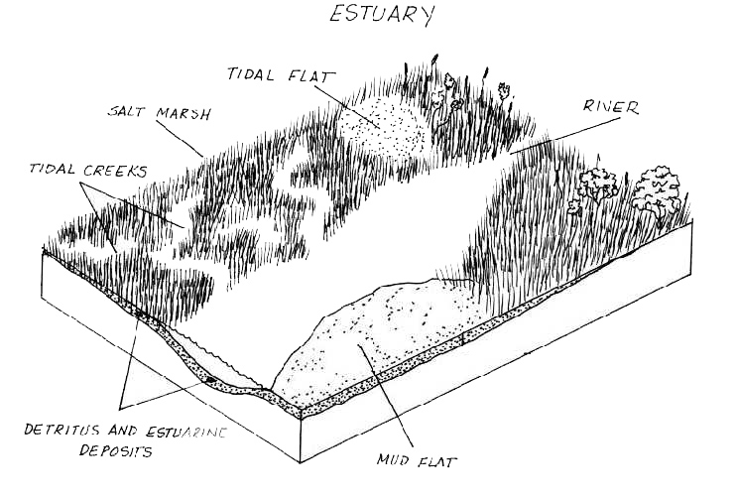

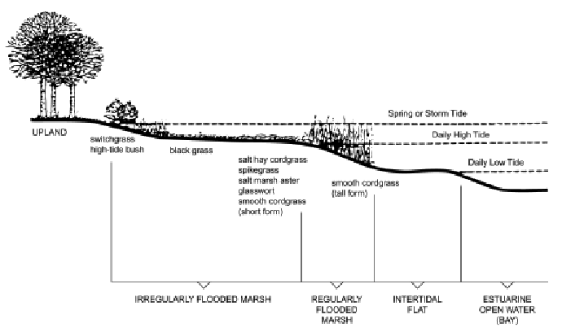
- Extend the exercise by identifying plants and animals that one can find in these environments.
- Ask students to list the most important functions of esturaies. These are:
(1) providing nursery areas for a large percent of marine life and needed habitat for millions of birds;
(2) providing food for most of these populations;
(3) providing shelter for many small marine animals;
(4) acting as a storm buffer to prevent floods and absorb energy from storms such as hurricanes; and
(5) detoxifying wastes.
- State the impact human use and misuse has on estuaries.
- Point out major coastal regions that can be seen on a large map. Identify estuarine environments of the Vietnam

Discussion: Threats to estuaries
Discuss with students why so many estuaries have been damaged or destroyed. Talk about
values, natural stresses, and human impact. Try to find solutions for misuse and destruction of estuaries.

Worksheet E2/1: ESTUARY

Directions: Look at the picture of the estuary and define smaller habitats found in this environment. On a separate sheet of paper write definitions for all the following terms that describe estuarine environments: tidal flat, salt marsh, tidal creeks, mud flat;
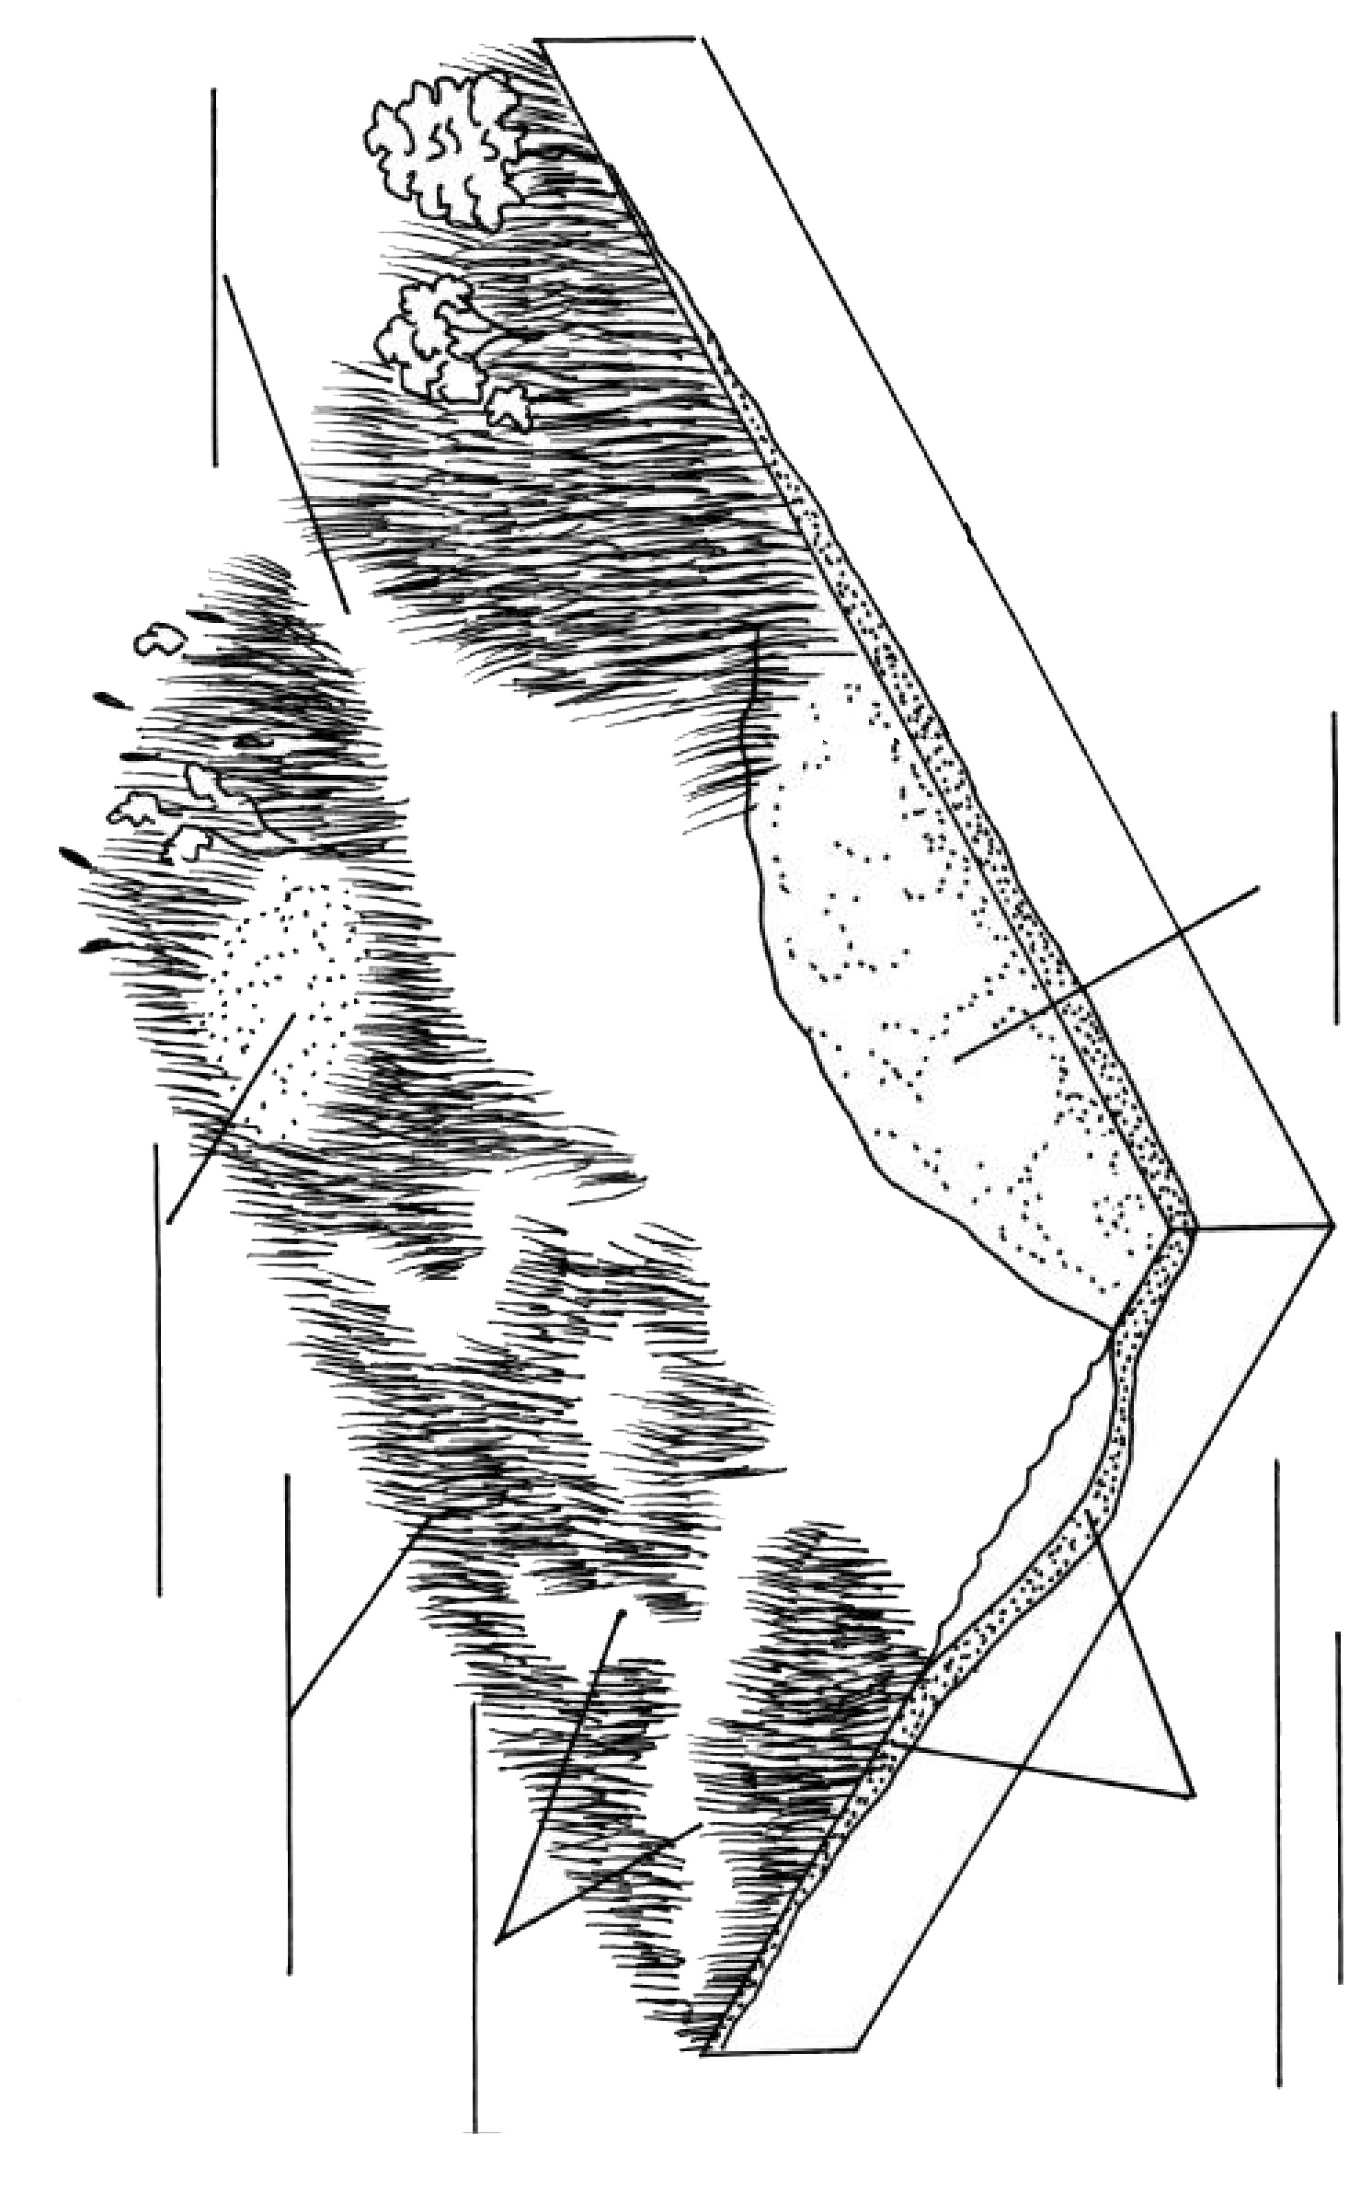

Lesson E3: DESTRUCTION OF COASTAL WETLANDS

Main idea: Coastal wetlands are vital to almost every form of wildlife in the coastal ecosystem. They also protect the coast from erosion and provide storm protection for inland communities. In the past, coastal wetlands (salt marshes, mangrove forests etc.) were viewed as waste places that bred mosquitoes and had no value. Therefore, many wetlands were destroyed and urbanized or used for agriculture or aquaculture. The formation of mangrove forests, for example, required many years, while people can clear a mangrove forest, fill in low-lying areas, and begin building housing developments and streets within a matter of weeks.

Goal: To present the negative effects of human activities in wetlands.

Concepts: coastal wetlands → salt marsh, mangrove forest etc. → urbanization, agriculture (rice fields), aquaculture (shrimph farms);

Introduction: Threats to coastal wetlands
Discuss with students why so many coastal wetlands have been damaged or destroyed.

Activity: Urbanizing a coastal wetland game
Materials: picture of animals that live in wetland (children can draw them or collect newspaper clipings), one large sheet of paper with a picture of coastal wetland (look at the picture and draw something simmilar), colored pencils, drawing paper)
- Show the students the large sheat of paper with a picture of a coastal wetland. Tell the students this is called a coastal wetland, which is an area near the ocean that is covered with a thin layer of water most of the time. It is the home of many different kinds of animals and plants.
- Play the game “Who Lives Here?”
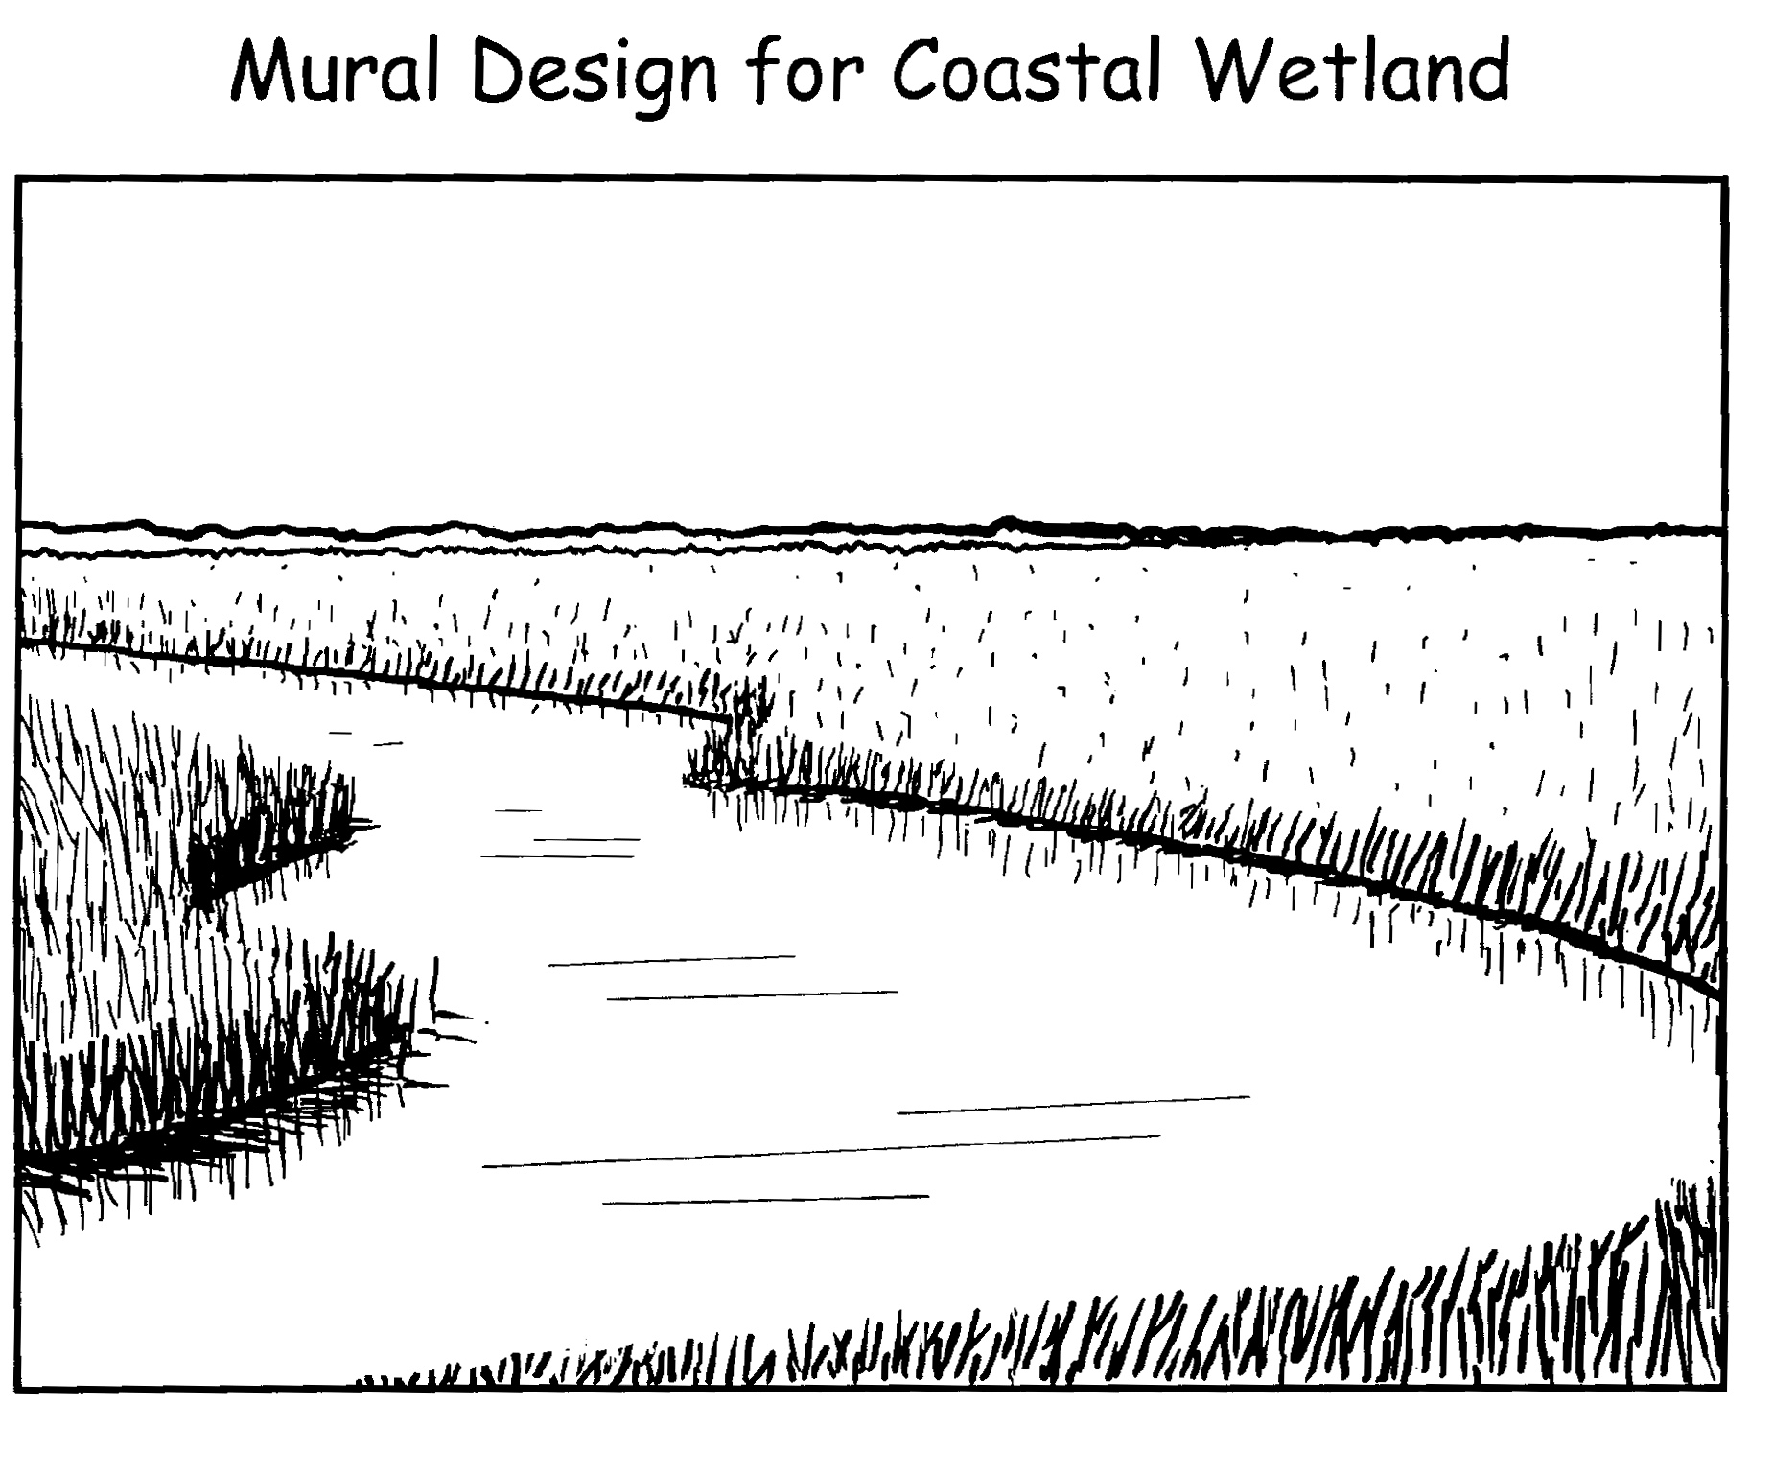

  - Have the students sit in a circle. Display the pictures of the different animals. Have the students arrange them into groups by asking, “Which of these animals live in a coastal wetland?” Place pictures of animals onto the mural. Discuss why they selected these animals.
  - Have a group discussion about life in coastal wetlands. Tell the students that the coastal wetlands provide important habitats for many types of sea animals and birds. It is also a home or habitat for waterfowl that fly south (migrate) when the weather gets too cold in the north.
  - Write a short paragraph about life in the coastal wetland listing all the animals who live in your wetland.
- Build a town. Tell the students that since this is such a beautiful place, we’re going to build a town here. Discuss and name some things a town needs in order for people to live, work, and grow (houses, hotels, grocery stores, malls, gas station, restaurant, factories, farm, park, fire station, hospital). Name the town. Write it on a piece of paper and place on your picture of the coastal wetland.
  - Put the students into pairs. Give each pair a name of one of the things needed to support the town people and a piece of drawing paper. Have each pair draw, color and cut out their building or park.
  - After the students have cut out the buildings, discuss the importance of each building to the town. Have each pair come up, select a site to put their building, and place it to the picture of the coastal wetland. Continue this until all the buildings are in place.
  - You could extend this further by placing streets on the board to connect the buildings. (Roads could be cut from adding toilet paper. Select the width and length to cut the paper from the dimension of the mural.)
- What happened to wetland? Ask the students to name the animals they can still see after the town has been built. Graph the number of animals again on a separate graph. Compare the two graphs. Ask the students:
  - What happened to the animals? (They died or moved away. The loss of the wetland habitat resulted in the loss of the animals.)
  - Why did they go away? (The town drained and filled the wetland site and/or polluted the water, and moved in taking over the different marine animals’ homes.)
- Discuss with students: What could we have done differently to have our town and save the coastal wetland habitat? (Locate upland from the wetland area, do not fill or drain the wetland, and designate the wetland as a national protected wildlife area.)
- After the discussion, relocate the town upland from the coastal wetland site.

Discussion: Protection of natural coast
Discuss with students possible ways to protect natural coast.
- Have the students report on some specific ways that mangrove forests are productive biologically and economically. Can they list fish and shellfish that people eat that rely on breeding grounds along mangrove coastlines?
- Look at old and new maps of your area or state. Are there any areas where there used to be wetlands that are no longer there? If yes, what happened to these wetlands?
- Have the students research how states are trying to convert some of their developed coastal areas back to their natural state.

Lesson E4: THREATS TO MARINE LIFE

Main idea: Pollution of our coasts and oceans is a serious problem. Our oceans are being used as giant garbage cans with humans putting in thousands of tons of garbage each year. There large quantities of waist water, urbanization of wetlands and many other human activities that threat marine life. There are many things people can do to help our oceans. Learning about the problem along our coasts and in our oceans is a good first step that can help us to find out much about this complicated problem.

Goal: To make students aware of different threats to marine life and their possible solutions.

Concepts: sea, coastal waters → pollution, overfishing, urbanization → marine debris, overgrowth of algae, contamination of shellfish, destruction of food chains, destruction of habitats, → marine life protectction

Introduction: Threats to marine life
Ask students to list possible threats to marine life. Remind them to the problems they discussed in the previous lessons (destruction of wetlands, pollution…). Try to list as many treats as possible.

Activity: Marine debris
Materials: two kilogram bag of sugar;

Remind students of the activity “Bogus fishfood” from the section A: “Water – basic characteristics”. Then share with the students the following: “Trash discarded in oceans and on beaches threatens the health and safety of people, birds, fish, and marine animals. An estimated 7 billion kiligrams of trash is dumped in the world’s oceans each year. Many sea birds and marine animals die each year from entanglement in marine debris or from eating plastic. Boats are often damaged by trash in the water.”

Take a field trip on a beach and record the type and quantities of marine debris found.

Discuss the number of trash:

Write a number “7,000,000,000 kilograms” on the chalkboard. Ask the children what that number is. Then tell them, 7 billion.

Pass around a two kilogram bag of sugar (let each student hold it). Write “2 kilograms” on the board. Say, “This bag of sugar weights two kilograms. Is it heavy? Every year people put 7 billion kilograms of trash in the oceans or on the beaches of the world. Is that a lot of garbage?

Most of the trash picked up on beaches is plastic. Discuss with students what does this mean.

Who are the main polluters? (Cities, boats... Large portion of that trash is from the worldwide fishing industry, which dumps an estimated 150,000 tons of plastic each year, including packaging, plastic nets, lines, and buoys.)

How long a piece of plastc can pollute the sea? (Plastics are lightweight and durable. Beverage 6-pack yokes may persist 450 years in the marine environment.)

What are the consequences of trash floating in seawater or lying on a beach? (There are milions of seabirds and marine mammals and other marine animals that die each year from entanglement in marine debris or ingestion of plastics mistaken for food. Waterborne debris fouls boat propellers and water intake structures, disabling engines, necessitating costly repairs, and creating a safety hazard for boat operators. Debris such as plastic sheeting becomes entangled in fishing nets. Trawling nets are often snagged and torn on oil drums and other heavy objects at sea.)

Discussion: Conserving coastal ecosystem

Discuss main problems related to conserving coastal ecosystems:

overgrowth of algae (nitrification);

contamination of shellfish (Many chemicals used in homes, offices, factories and farms are washed into the sea.)

destruction of food chains (by overfishing, destructuion of breading places, contaminatin…)

overfishing (the population of fish has difficulty to renew)

filling in coastal wetlands (loss of wetlands);

