Part 1: Water, Water Environments and Natural Processes

Section F:

FLOODS AND EROSION

Floods and erosion are basic natural processes that contribute to shaping the Earth’s surface.
On the land, water currents dug deep into the earth surface and created steep mountains and narrow valleys. By transporting and depositing enormous quantities of sediments often far away from its source over millions of years, they created vast planes that today represent some of the most fertile lands on the earth.
On the coast, water currents and water waves created steep cliffs on one hand and vast sandy beaches with dunes on the other.

RIVER FLOODS AND SOIL EROSION
Soil erosion by water
In the upper sections of rivers, we can often witness extensive soil erosion by water. Heavy rains can cause flashfloods on steep sloping areas in the mountains. Flashfloods are specially triggered at locations where trees and plants are destroyed leaving bare grounds, where there is almost no vegetation and soil. The bare grounds cannot absorb the water and cannot slow down the speed of the water. The eroding soils can create landslides destroying houses and blocking roads. This soil erosion by water, repeated many times, ruins land for most uses.

River floods
In general we do not like floods, but there are some great exceptions:

Case: River Nile Floods in Egypt
Floods can also contribute to our benefit and increase the fertility by depositing fertile mud on the agricultural grounds. This was the case in Ancient Egypt where the floods of river Nile every year brought large amounts of fertile mud to the Nile valley and delta, which is used for agriculture during the last 5000 years. The High Aswan dam (1964) is built to produce electricity, to regulate floods and to provide all year round irrigation water. The agricultural productivity has risen strongly from one crop per year to three crops on many agricultural plots. Apart of these positive effects, also negative ones are noticed such as: large quantity of fertile mud and sand slowly fill up the lake behind the dam reducing its life time, strongly increasing coastal erosion 1200 km downstream, strongly increasing quantities of costly artificial fertilizers to compensate the (since 1964) missing fertile mud. The soils in several coastal areas of the Nile Delta Due is losing its fertility due to changed hydrological conditions. This salinity problem is being solved by making a large scale, drainage system separated from but in coherence with the irrigation system and land-use in this semi-desert climate country.

Contrary to the floods of the river Nil in ancient Egypt, we are generally afraid of large-scale floods occurring in the lower sections of rivers, affecting large areas and large number of persons. These floods can destroy everything that is in their way. It is not the yearly river floods that frighten us. We are afraid of exceptionally high floods caused by long lasting and heavy rains often associated with typhoons.
People are heavily affected by floods, since these natural events are often unpredictable. In the mean time, people are influencing these natural processes mainly through settlement and deforestation, as well as through changing other land-use patterns.
More and more people are migrating to the river and coastal plains. They settle, making their houses in the fertile river flood plains and coastal plains of Vietnam. This means that more and more people are also settling in vulnerable areas: (1) where floods are hitting the lowest lying parts of the floodplain and (2) where erosion is dominant like the outer bends of meanders. The larger the population pressure on vulnerable flood plain areas, the more flooding and erosion become a problem.
To protect homes and property from floods, we regulate rivers and build ditches to drain the water, dikes and dams to serve as water accumulating reservoirs. Some of these protection measures are not cheap. We also construct houses on poles to survive flooding and we move to our second floor for many days during floods.
It can also be wise to analyze the vulnerable, often flooded areas and to plan and implement adaptive measures to safeguard the development of natural resources. Adaptation may include: to set up a zoning plan in a river plain and in a coastal plain, which delineate areas to be developed according to their vulnerabilities in an integrated fashion. The implementation of such a zoning plan will contribute to decrease the flooding risks for the low river plain and coastal inhabitants.

COASTAL FLOODING AND COASTAL EROSION

Coastal flooding
Twice per day high and low water can be observed along the coastline of the TT Hue province. The tidal rise and fall are in response to the gravitational pull of the Sun and the Moon: the astronomic tide. Twice a month during spring tide, the astronomic high water level is at is highest level. These astronomic high levels occur two days after full and new moon.
A tropical storm/typhoon can increase the sea level in two ways. A typhoon is an atmospheric low-pressure area, which in itself cause a rise of the sea level, amounting to several decimeters. Furthermore during the passage of a typhoon, the increase of waves heights due to wave set up (storm surges) may account for several meters in the near shore zone. The coastal floods are even more damaging when the passage of the typhoon coincides with high tides.
The coastal floods can break or overflow coastal beach barriers and sea dikes. The flood brings seawater inland and prevents river water from flowing to the sea, causing floods by the river at its very low end.
About two to three heavy tropical storms are passing the TT Hue coastline each year during the autumn. The general impression exists, that the eroding effects of these storms are more or less restored during the subsequent spring and summer period.
The November 1999 typhoon was an exceptional heavy one. This typhoon caused extensive coastal, river and lagoon flooding, and several casualties and extensive damages in the TT Hue province. Monitoring the extent of the flood e.g. using Satellite Images will increase the capabilities of Provincial authorities to minimize damages of the next typhoons.
Apart from typhoon, large surges more than 10 meters in height, can be caused by tsunamis, originated by submarine earthquakes. When such a surge reaches the coastline it can result in extensive flooding, erosion, property damage, and loss of life, such as in the case of tsunami in Asia in December 2004. Happily enough these very severe and devastating extreme events do seldom occur.
Case: Tsunami in Asia in Decenber 2004
The 2004 Indian Ocean earthquake, known by the scientific community as the Sumatra-Andaman earthquake, was an undersea earthquake that occurred at 00:58:53 UTC (07:58:53 local time) on December 26, 2004. A magnitude 9.0 earthquake occurred off the west coast of northern Sumatra, Indonesia. The epi-centre was located under sea water at 3.32 N 95.85 E. This is the fourth largest earthquake in the world since 1900. The earthquake generated tsunamis which swept across the Indian Ocean within hours. Areas near to the epicentre in Indonesia, especially Aceh, were devastated by the earthquake and tsunamis. The tsunamis also affected Phuket and surrounding areas in Thailand, Penang in Malaysia, Sri Lanka, India, and places as far as Somalia in Africa. The earthquake was the result of the sliding of the portion of the Earth's crust known as the India plate under the section called the Burma plate. The process has been going on for millennia, one plate pushing against the other.
The earthquake itself lasted close to ten minutes when most major earthquakes last no more than a few seconds; it caused the entire planet to vibrate at least a few centimetres. The earthquake was unusually large in geographical extent. The total energy released by the 2004 Indian Ocean earthquake has been estimated as 3.35 exajoules, which is equivalent to 0.8 gigatons of TNT. The total energy of the tsunami waves was about five megatons of TNT, which is more than twice the total explosive energy used during all of World War II (including the two atomic bombs). In many places the waves reached as far as 2 km (1.24 mi) inland.
By the end of the day more than 220,000 people were dead or missing and millions more were homeless in 11 countries, making it perhaps the most destructive tsunami in history. Despite a lag of up to several hours between the earthquake and the impact of the tsunami, nearly all of the victims were taken completely by surprise; there were no tsunami warning systems in the Indian Ocean to detect tsunamis, or equally importantly, to warn the general populace living around the ocean. Tsunami detection is not easy because while a tsunami is in deep water it has a very low height and a network of sensors is needed to detect it. Setting up the communications infrastructure to issue timely warnings is an even bigger problem, particularly in a relatively poor part of the world.
Epidemics were of special concern, due to the high population density and tropical climate of the affected areas. It was important to provide sanitation facilities and fresh drinking water to contain the spread of diseases such as cholera, diphtheria, dysentery and typhoid.
Beyond the heavy toll on human lives, the Indian Ocean earthquake has caused an enormous economic and environmental impact that will affect the region for many years to come. The impact on coastal fishing communities and fisherfolk, some of the poorest people in the region, has been devastating with high losses of income earners as well as boats and fishing gear. It has been reported that severe damage has been inflicted on ecosystems such as mangroves, coral reefs, forests, coastal wetlands, vegetation, sand dunes and rock formations, animal and plant biodiversity and groundwater. In addition, the spread of solid and liquid waste and industrial chemicals, water pollution and the destruction of sewage collectors and treatment plants threaten the environment even further, in untold ways. The environmental impact will take a long time and significant resources to assess. The main effect is being caused by poisoning of the fresh water supplies and the soil by salt water infiltration and deposit of a salt layer over arable land. Uncountable wells that served communities were invaded by sea, sand and earth; and aquifers were invaded through porous rock. Salted-over soil becomes sterile, and it is difficult and costly to restore for agriculture. It also causes the death of plants and important soil micro-organisms. Thousands of rice, mango and banana plantations in Sri Lanka were destroyed almost entirely and will take years to recover.

Coastal erosion
Besides these extreme flooding events, rivers carry new sediments to the coast, building deltas and widening beaches. The daily, forces of the waves and the tidal currents create complex patterns of coastal erosion and accumulation / deposition of sediments. Therefore, coastal lands are constantly changing.
Waves are the primary cause of coastal erosion. The larger the waves, the greater their erosive power; thus, storm-generated waves cause the greatest coastal erosion. Breaking waves can undercut cliffs and break down rocks and sediments into smaller and smaller pieces. Because breaking waves do not always approach the coast straight-on, longshore currents can form along the coast, flowing in the direction of wave movement. Sediment moves gradually along the coast until an obstacle, such as a jetty, is encountered. Water flow is slowed and the sediment is deposited.
Erosion can cause problems of land loss. Long-term accumulation of sediments in certain locations can create profitable new land. In the mean time, accumulation can also cause troubles e.g. in harbor entrances deposition of sand can prevent ships to enter the harbor.

Case Erosion and accretion in The Nam Dinh coastline
The Nam Dinh coastline has a tortuous shape, which alters very often due to erosion and accretion processes. For the two alluvial grounds in the Giao Thuy and Nghia Hung districts, every year the rivers provide large volumes of deposited silt, which accretes and enlarges the grounds by hundreds of metres. In contrast, the coastline of 40 km of Hai Hau district faces erosion. The cause of the erosion can be explained as follows: the Nam Dinh coastline topography is relatively flat, running in the NE - SW direction, without protecting objects; the shoreline is at a low level; the coastal deep-contours are very close to each other; all such conditions are very disadvantageous, enabling strong waves to attack the coastline and cause erosion and dyke collapse. The section from Hai Ly commune to Hai Trieu commune is at present subject to the most drastic erosion. At that section, the eroding speed is 10- 20m per year.
The coastline erosion results in serious economic consequences such as: loss of cultivated and residential land, adverse impacts on the production establishments, damages and threats to the coastal dykes and embankments and other social consequences to coastal communities, especially the communities of the Hai Hau district, as a result of retreat and resettlement.

Lesson F1: SOUNDS OF RAIN AND THUNDERSTORM

Main idea: Floods and erosion are natural processes and can be connected to storms and extensive rain. Extensive rain can be comparatively speaking:
- moderate rain, but it lasts for a long period of time or
- heavy rain such as during storm or thunderstorm.

Goal: To become more aware of the various sounds of precipitation through mimicking the sounds of rain, storm and thunderstorm, and to explain that extensive rain can be a cause of floods, landslides and coastal erosion.

Concepts: precipitation, rain → storm, thunderstorm, extensive rain → typhoon → floods, landslides, coastal erosion;

Introduction: Sounds of rain
Ask students to imagine rain and other forms of precipitation:
- What are different forms of precipitation?
- How does the rain, snow or typhoon look like?
- What are the sounds of rain, storm etc.?

Activity: Making rain sounds with the rainstick.
Materials: Cardboard tubes from paper towels or gift wrapping, bamboo tubes etc, a tool to punch holes in the tube, such as a drill or awl, small hammer; Toothpicks or flat head nails; Glue; Masking tape; Wire cutters or sturdy scissors; Fill: seeds, pebbles, rice, sand, dried beans, shells, beads...; Materials to decorate the outside of the tube: paint, crayons, sand, etc.
- Have the students think about different sounds of rain: small drops / large drops, soft grounding / hard grounding etc.
- Make your own rainstick:
- Drill or poke holes in the tube. Creating a spiral staircase pattern, place the holes about 2cm apart. Drill the holes through one side only or all the way through both sides of the tube. If you are using nails, it is not necessary to drill holes.
- If you use toothpicks, push the toothpicks through the holes. Leave a little bit of the tooth- pick (a nub) remaining outside the tube. If holes were drilled straight through the cylinder, push the toothpick all the way through the tube. Inserting the toothpicks to different lengths will produce a variety of sounds. If you are using nails, insert nails that are slightly shorter than the diameter of the tube in a spiral pattern. A small hammer may be useful.
- Apply glue to the nubs and allow to dry. Cut off the nubs if they stick out from the tube. Or, seal the nail heads with glue or wrap the entire tube with masking tape.
- Seal one end of the tube with masking tape. Pour in the fill. Cover the open end of the tube with your hand and invert it. Close your eyes and listen. Add more fill or take some away to create a sound that is pleasing to you.
- Cover the other end of the tube with masking tape. You may wish to decorate your rainstick by coating it with glue and rolling it in sand. (Messy, but it provides a wonderful texture for the surface of your instrument.) After it dries, you may paint and decorate it.
- When you slowly turn your rainstick end to end, listen for the sound of the rain. What do you hear? What kind of rain can you simulate? Make more rainsticks using different materials and different fills to create various sounds.
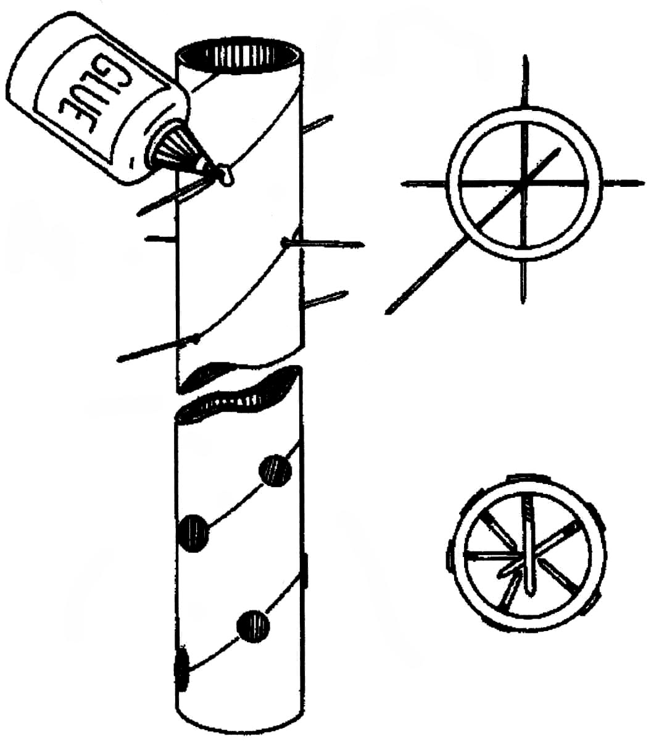
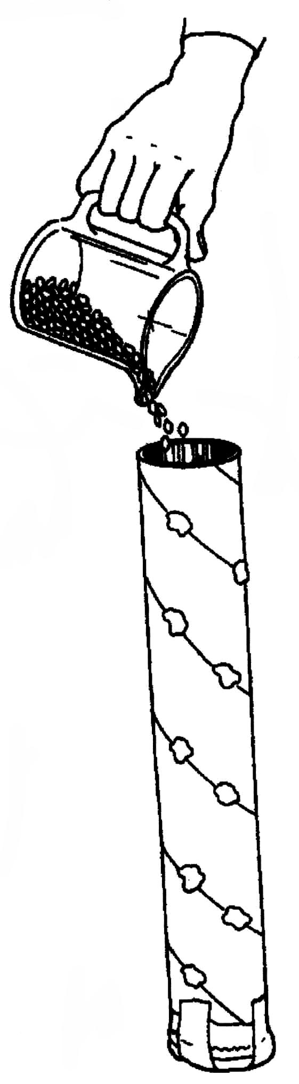
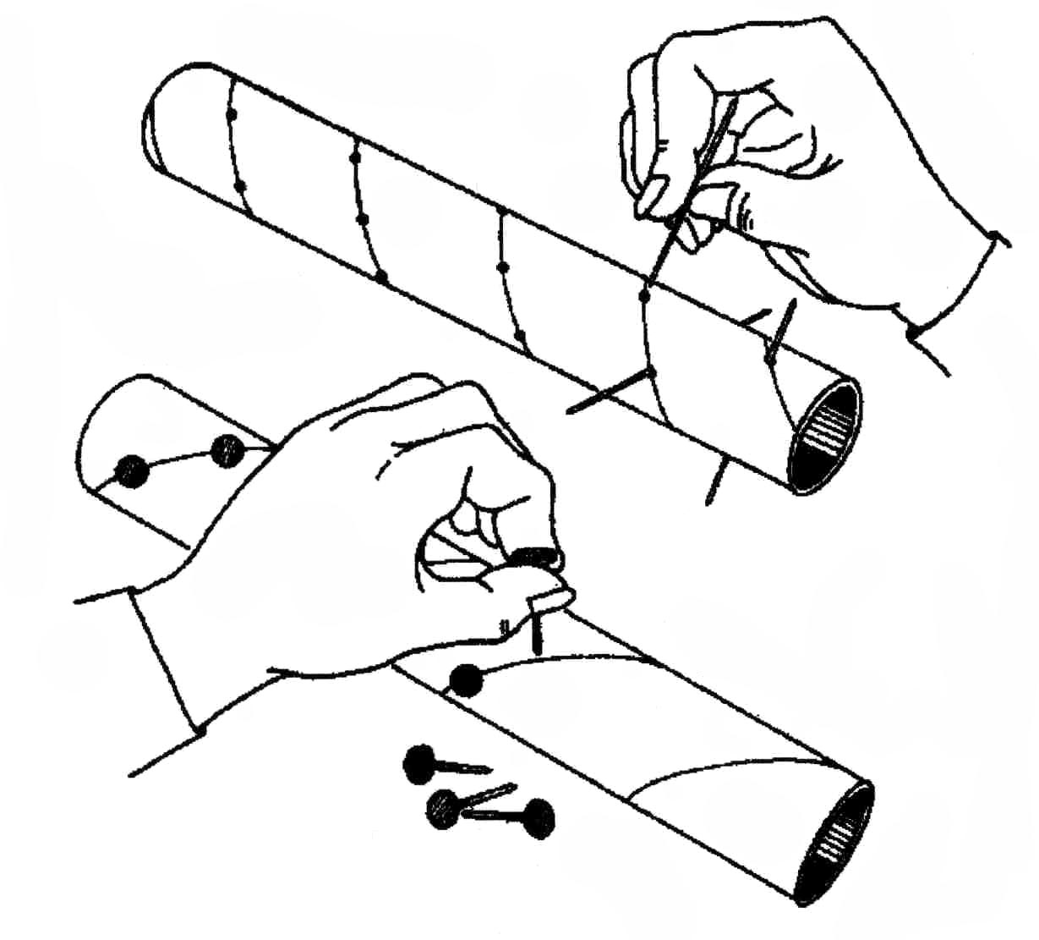

Activity: Thunderstorm game
Materials: Nothing special, just open space.
- Have students describe how they would feel if they heard that a large thunderstorm with lightning, heavy rain, small hail, and gusty winds is moving toward their town, and that people in the path of the storm are advised to take precautions.
- Have students outline the precautions they should take.
- Ask students to create a mental picture of the approaching thunderstorm.
- Ask students to stand in a semicircle in front of you. Explain that when you make eye contact with or point to a student, he or she should imitate your motion. The student should continue making the motion until you make eye contact again and show a new motion. Start with a student on one end and begin the first motion. Continue the motion as you make eye contact with each student down the line. Return to the first student and start the second motion. This will create a crescendo as the sounds produced move from one end to the other. Using this strategy, lead students through the following series of motions:
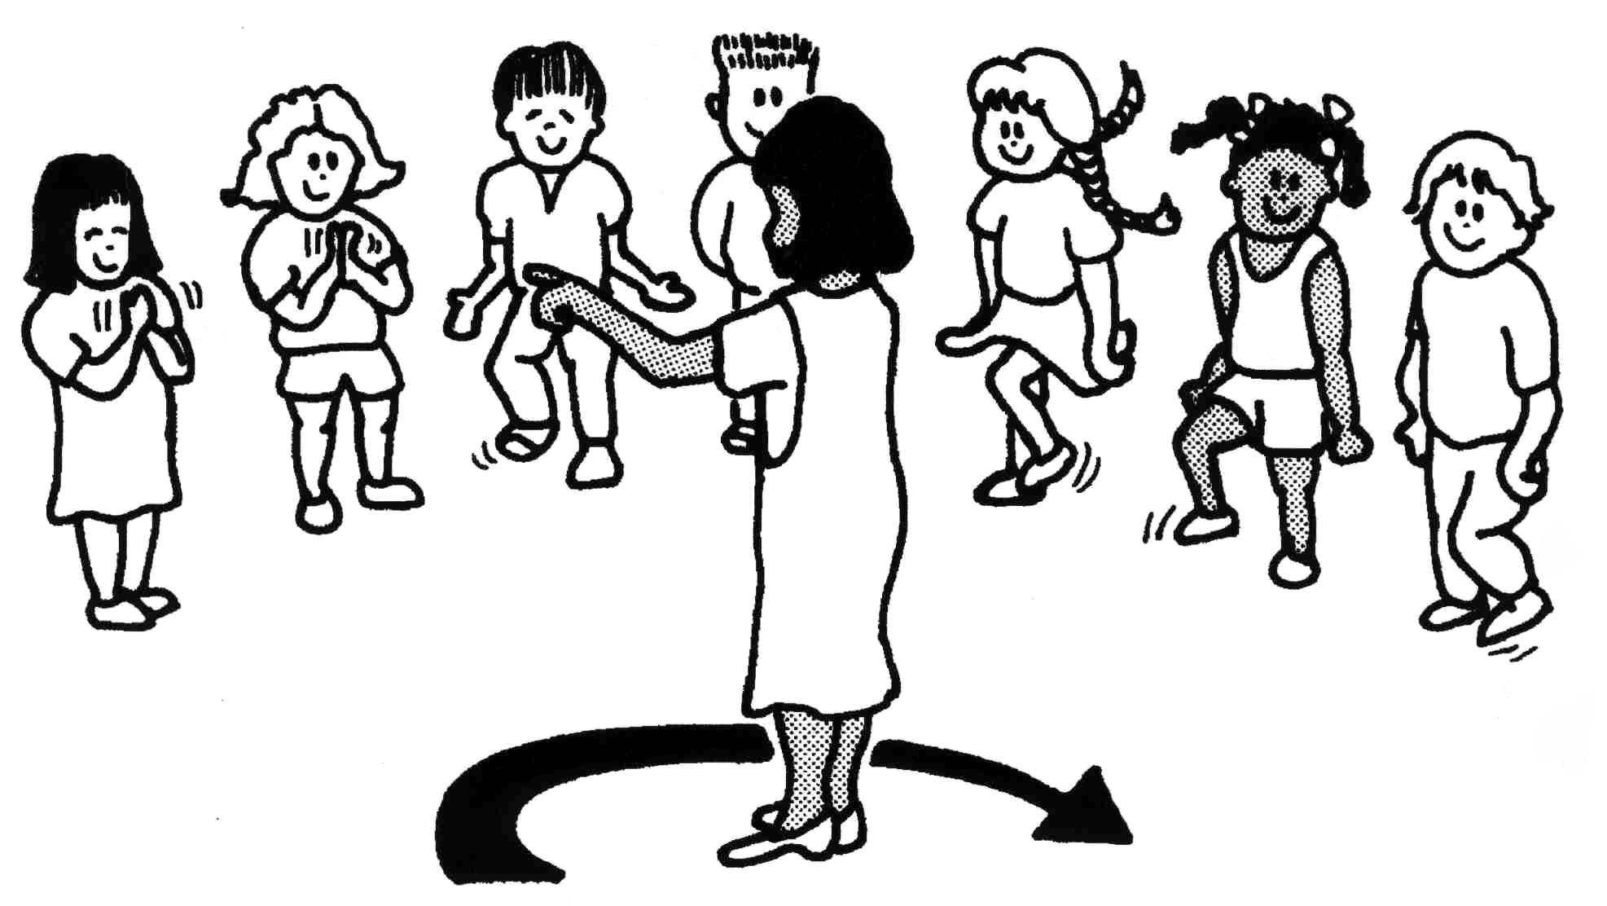
- rub your hands together, snap your fingers;
- clap your hands together in an irregular cadence;
- slap your hands on your legs;
- stomp your feet;
- slap your hands on your legs and stomp your feet (represents height of the storm);
- stomp your feet;
- slap your hands on your legs;
- clap your hands together in an irregular cadence;
- snap your fingers;
- rub your hands together open palms (quiet).
- When all students are standing with open palms, have them remain silent for a minute to think about the exercise and to catch their breath. Discuss each motion and the effect it mimics.
- Have students write stories or draw pictures about thunderstorms they have experienced.

Activity: Rain and thunderstorm game
Materials: Nothing special.
- Children sit in a circle; teacher mentions words thunderstorm, storm, wind or rain, and children have to imitate the phenomena by clapping hands, stamping feet and “woeing” with their mouth.

Discussion: Thunderstorm and typhoon
- What distinguishes a thunderstorm from other types of storms? (Thunder and lightning.)
- What causes thunder and lighting? (Electrical charges build up and move about within certain kinds of clouds, for example, a cumulonimbus cloud that contains large amounts of moisture. When these charges jump from one area of the cloud to another, to another cloud, or to the ground, lightning occurs. The electric current in the lightning stroke heats the air it passes through. This heat causes an expansion of the air along its path and creates a shock wave of sound-thunder.)
- Is thunderstorm dangerous? (Although thunderstorms can cause destruction through high winds, hail, heavy rains, and even tornadoes, most storms only pass through, bringing moisture.)
- Is it possible, that thunderstorm develops into a typhoon? (In tropical areas, thunderstorms may develop into violent storms with torrential rain, and wind speeds reaching as much as 300km per hour. Typhoons form only above tropical seas between the latitudes 5° and 20° north and south of the equator, where the sea temperature is above 27°C, and so the conditions of heat and moisture are at their extreme.)
- What kind of damage can be caused by typhoon? (The November 1999 typhoon was an exceptional heavy one. This typhoon caused extensive coastal, river and lagoon flooding, and several casualties and extensive damages in the TT Hue province.)

Lesson F2: RAINFALL MONITORING

Main idea: It is important to monitor the amount of precipitation released by extensive rain and thunderstorms, because a larger quantity of rainfall in a short period of time in a limited area may cause extensive flooding, landslides, and coastal erosion. To be able to predict the danger of such natural occurrences, monitoring of precipitation is essential.

Goal: To present the students how to monitor and record precipitation, and to make them aware of the importance of a rain monitoring system for increasing the level of security from big floods, landslides and coastal erosion. Students should learn how extensive rain and thunderstorms could affect their lives.

Concepts: recording precipitation → rainfall monitoring system → floods and coastal erosion protection → floods and coastal erosion warning system

Introduction: Measuring rain
Brainstorm with children about measuring rain and its consequences.
- Can rain be measured? How?
- Why can measuring rain be useful??

Activity: Rain gauge
Materials: plastic or metal funnel, piece of firm plastic, big plastic or glass container, flat ground in the open space, ruler;
- Make a rain-gauge:
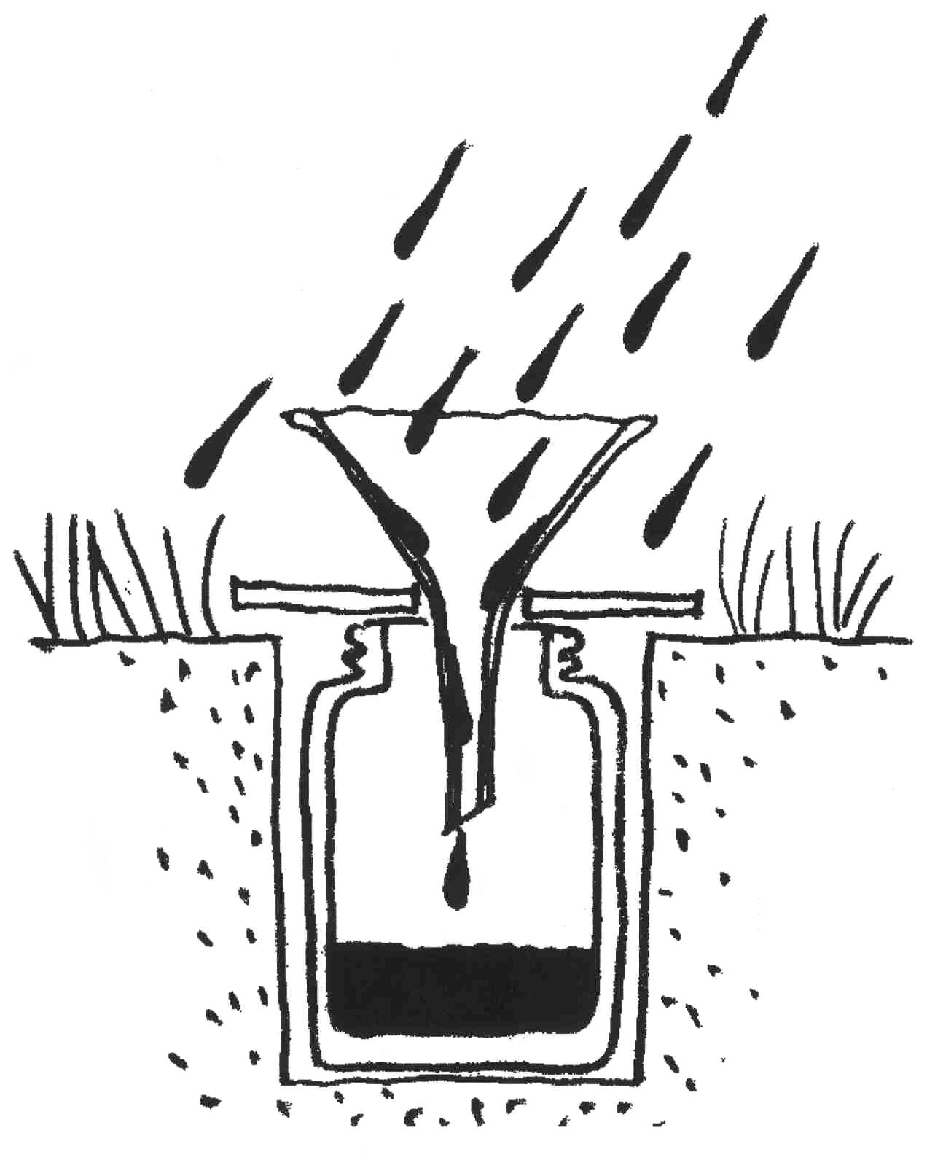
- Make a hole into the ground and put the container (plastic or glass) into the hole.
- Make a hole into the firm plastic piece.
- Put the smaller end of the funnel into a hole (the hole must be big enough). Than put the plastic with the funnel on the top of the container in the ground, and your rain gauge is ready to use.

- After every raining day measure the height of water in the container and make notes of your measurements.
- Is there any difference in the amount of water in the container if the rain was slight or if it was heavy?

Activity: Monitoring rainfall and creating rainfall maps
Materials: hundreds of small pieces of paper (1 cm squares), paper and pencil;
- Discuss why and how students think that monitoring of rainfall is done.
- How precipitation is monitored? (Precipitation is monitored through a network of recording stations. Each station collects data that is transmitted to scientists.)
- How the measurements are presented? (Scientists use graphs and maps to illustrate their measurements. Graphs and maps make the data easier to visualize and understand.)
- What is the purpose of such a map? (To identify areas that have similar amounts of precipitation.)
- Explain students that they will simulate monitoring rainfall with a simple game:
- Have students arrange their chairs in rows to form a grid and sit on them. Each chair represents one point in the monitoring network.
- Give a container filled with pieces of paper to one student. Tell the student that when you say "Now!" he or she should toss the paper into the air.
- Repeat the thunderstorm activity (from Lesson 1 in this section). At the height of the storm, when students are stomping feet and slapping hands on legs, say "Now!"
- After the last sounds fade, ask students to be seated. Tell students that the pieces of paper represent the amount of rainfall. Have them gather as many pieces of paper as they can without leaving their seats.
- Making the rainfall map:
- Calculate the amount of precipitation by counting each piece collected as one millimeter of rain.
- Draw the grid of the student monitoring stations.
- Record the number of pieces of paper collected by each student in the corresponding square on the grid.
- Locate the area that received the most precipitation and mark it with an "X."
- Draw a line connecting the stations with similar amount of rain. The end result will be a circle that connects stations with 50, 40, 30, 20 and 10 millimeters of rainfall. The lines should not cross.
- Repeat the activity several times to generate different maps.
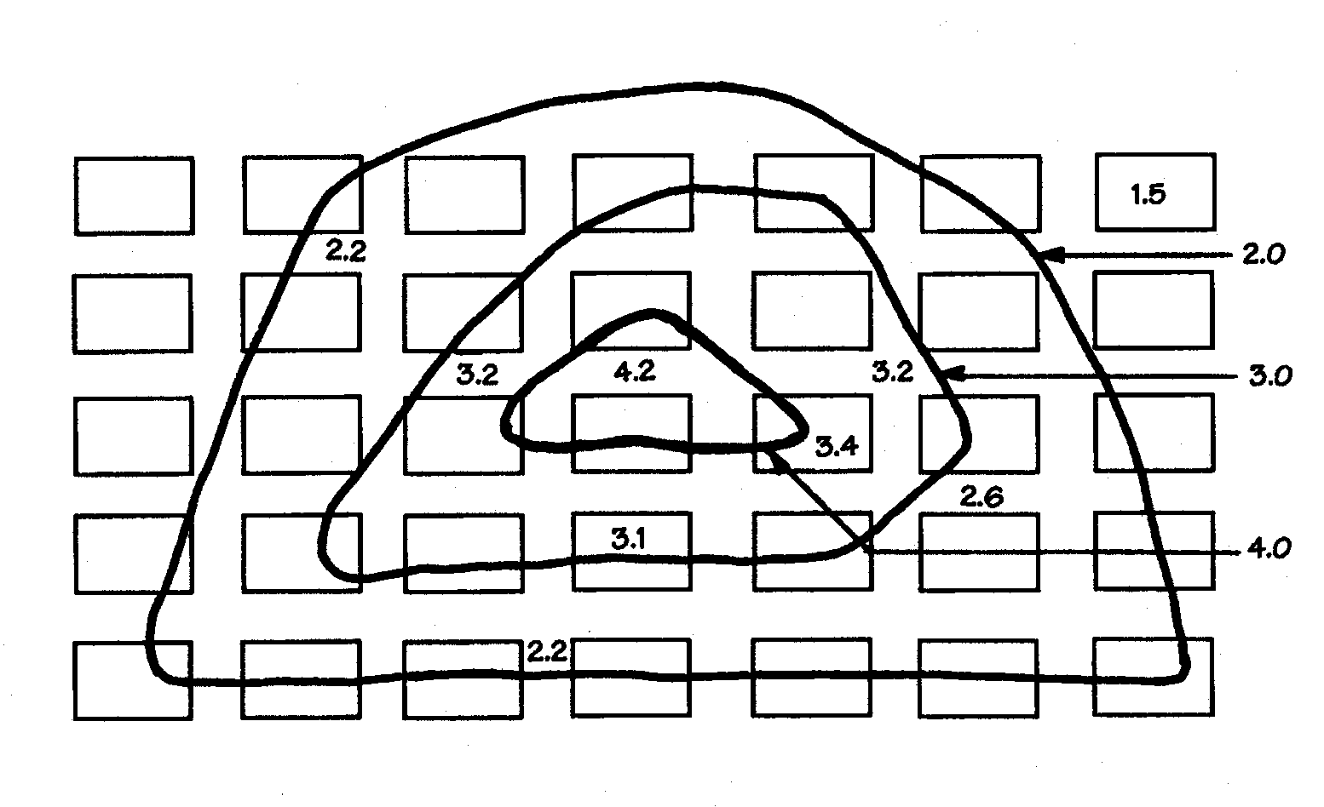
- What are the ‘circles’ on the map? (The ‘circles’ are called isohyetal lines = contour lines of precipitation). Theoretically, they indicate that every point along the line is of equal value.)
- How a hydrologist might use the data from the map (flood predictions, irrigation...).

Discussion: Rainfall monitoring
Have a discussion about the importance of rainfall monitoring:
- How many millimeters of rain do you get in your area in a typical year? How much of that in wet and how much of that in dry season? What season in your country is the rainiest? Why can this be an important information? (for predicting big floods...)
- Why is monitoring rainfall important? How we can use it? (Rainfall monitoring is essential to be able to predict the danger of flooding, landslides, coastal erosion, and to be able to take all the necessary precautions. A record of rainfall measurements can also helps river basin managers predict possible water shortages. If there is a chance that water supply may be affected, managers may need to implement water conservation strategies.)

Lesson F3: RIVER FLOODS

Main idea: Floods occur naturally and depend mainly on quantity of precipitation. Heavy rain causes the level of water in rivers, lakes or other body of water to rise and overflow riverbanks. To live safely on riverbanks of rivers and lakes, one should know where and when rivers flood, and should use the land in accordance to the flooding nature of the area.

Goal: To present reasons for river floods and discuss what can be done to prevent catastrophes.

Concepts: river, precipitation → floods, floodplains, catastrophe → appropriate and inappropriate land-use, flood protection measures;

Introduction: River Floods
Have a discussion with students about their experiences of floods and their understanding of reasons why they occurred.
- Have you ever experienced or seen floods? Why have they happened?
- When do we have floods in Vietnam? Which months they usually occur?

Activity: Flood model experiment
Materials: wide clear plastic container, water, clay or plasticin, two soup can with holes, two cups, small pieces of metal or hard plastic, sheets of sponge;
- Explain students that they will create a model of landscape with river and small lake to explore floods. Making the model:
- Take a wide clear plastic container and make a very narrow “v” opening on one edge to create the outflow of a lake (or lagoon).
- Put clay or plasticin in the wide clear plastic container and build with it a landscape with hills on one side and wide plane with a lake (or lagoon) on the other side.
- Place the “mountain” side of the container higher to create a little bit of slope.
- Take the soup can with holes, add water and let it rain on a model until the water from the lake starts to flow from the model.
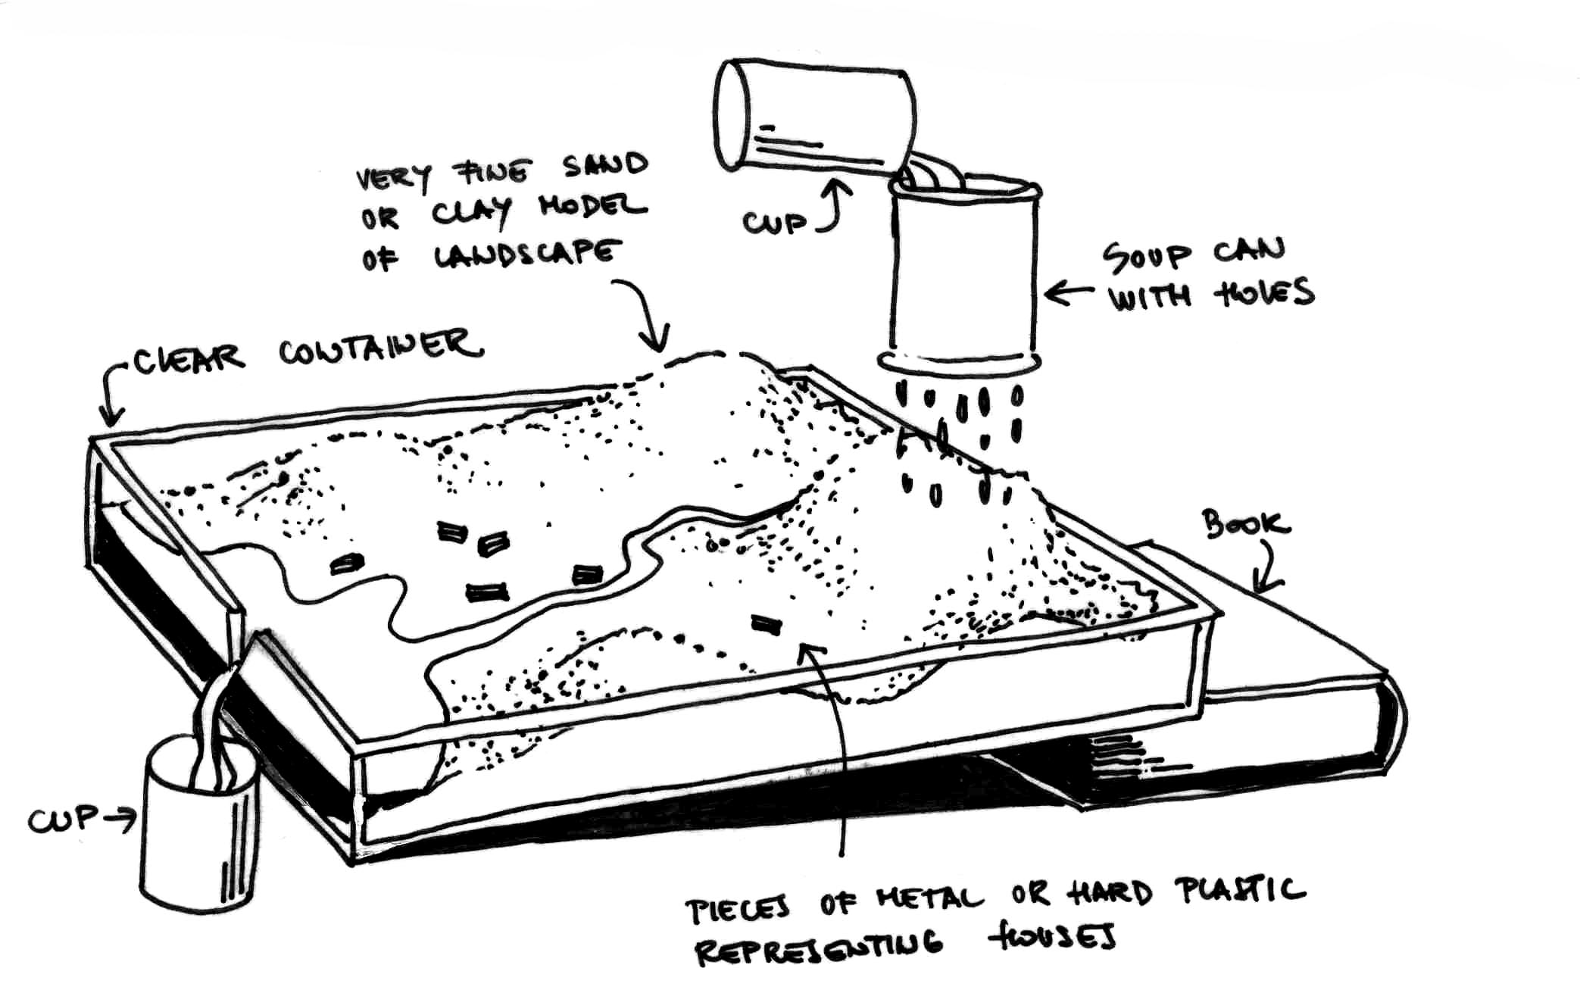
- Explain students that they should draw a map of their landscape in order to be able to record floodplains. Wait until the water stops to flow.
- Observe the model and draw the map of situation including, the river, lake and the hills. On the sides of your model draw a water level in your lake.
- Place small pieces of metal or hard plastic representing houses and villages on the model in a way you like. Record the positions of your villages in your map.
- Explain students that they will create floods. Discuss with them weather they located their villages safe from flooding or not.
- Have two students create rain from soup cans with holes using two cups of water each. The rest of students should observe the model:
- Which houses were flooded at the peak of the flood? What area was flooded?
- What was the highest level of water in our lake in the model?
- Record the flooded areas on your map. Draw also the highest level of water in a lake that was reached during the pick of flood.
- Is there a need to protect any of the villages from floods, or maybe even to relocate any of them? How can villages be protected from floods?
- Explain students that they will explore the influence of vegetative cover on floods, since vegetative cover, like forest, marshes or meadows, is suppose to accumulate water.
- Use layers of sponge representing forest to cover the model. Make sure that the sponge is dry.
- Have two students create rain from soup cans with holes using the same amount of water as at the previous step of the experiment. The rest of students should observe the model:
- Is the flooded area of the same size as in the previous step or smaller? Why is it smaller? (water is accumulated in the forest)
- Which houses were flooded at the peak of the flood? What area was flooded?
- What was the highest level of water in our lake in the model?
- Record the flooded areas on your map. Draw also the highest level of water in a lake that was reached during the pick of flood.
- Is there a need to protect any of the villages from floods?
- Why flood recording is important? (planning flood protection...)
- Have two students continue creating rain from soup cans with holes using several cups of water. The rest of students should observe the model:
- What is the size of flooded area? Why is it the same size as in the case without the vegetative cover? Vegetative cover can accumulate only a limited quantity of water.)
- In the next step, students will explore some of the flood prevention measures:
- Secure villages that were flooded by building dikes.
- Have two students create rain from soup cans with holes. Make sure, that it rains mainly in the mountains. The rest of students should observe the model:
- Are still all the houses safe from floods?
- Why some of the houses are still flooded? (dikes were not high enough...)

Discussion: Flood protection
Have a discussion with students about floods and flood protection:
- Why do we have floods? (Floods may occur for several reasons. For instance, if large amounts of rain fall and there is too much water to drain away. Flooding also occurs when sea level rises, or when a land is swamped by waves caused by storms.)
- How can we protect our homes from floods? (By building dikes, regulating rivers, protecting floodplains from urbanization... Also building small dams on upper tributaries in a watershed help control runoff and help solve problems of too much water one time and not enough another time.)
- Can urbanization of lowlands cause more floods? (Yes, when floodplains are urbanized and protected from floods by dikes, water floods other areas to compensate for the loss of space and volume.)
- Have urbanization in general any influence on floods? (In cities and suburbs, where much of the land is paved or covered - streets, buildings, shopping centers, airport runways - rainwater runs off as much as ten times faster than on unpaved land. Since this water cannot soak into the soil, it flows rapidly down storm drains or through sewer systems, contributing to floods and often carrying debris and other pollutants to streams.)
- How often does a 100-year flood occur? What about 10-year flood or 1.000-year flood? (A 100-year flood statistically occurs once in 100 years, 10-year flood once in 10 years and 1.000-year flood once in 1.000 years.)
- There is a very little chance that one wins the lottery. But, some people do. What is a chance that 1.000 year flood will occur tomorrow? (Almost zero. But when it occurs, many people can be affected.)

Lesson F4: SOIL EROSION

Main idea: Sediment results from the erosion of land surfaces and streambanks. A rainstorm or a heavy shower on bare soil loosens soil particles, and runoff carries these particles away. This action, soil erosion by water, repeated many times ruins land for most uses. Erosion, furthermore, is the source of sediment that streams carry downstream breaking it into smaller and smaller particles. The sediment can shorten the useful life of dams and reservoirs. Falling rain erodes any raw earth surface. Bare, plowed farmland, cleared areas going into housing developments, and highway fills and banks are especially vulnerable. The water erosion in its intensive form can form landslides. One of the most effective means of controlling soil erosion is to protect the land surfaces and streambanks with vegetation. Vegetation helps prevent erosion by holding soil in place. The vegetation canopy and the tree-leaf litter protect soil from the impact of raindrops, which can increase erosion.

Goal: To demonstrate the effect of rainfall on soil erosion, and the effect of vegetative cover and vegetative litter on the reduction of soil erosion.

Concepts: rainfall, soil → soil erosion, vegetation → prevention of soil erosion;

Introduction: What is soil and what soil erosion
Have a discussion with children about the ground beneath their feet:
- What is the ground made off? (rocks, sand, soil)
- What is soil? (Soil is made when rocks are broken down into sand, silt and clay. Rotting plants, animal maneuver, and rotting dead animals add organic material. Numerous microscopic creatures in the soil change the organic material into nutrients that plants need to grow. Soil is a living material composed of mineral material, organic material and microscopic creatures.)
- Do you know where the vegetables we eat come from? (Nearly everything we eat comes from the soil. Plants need soil to grow. Animals need plants to eat.)
- What happens with the soil when it rains? (It gets washed away. This process is called erosion.)
Activity: Soil erosion model
Material: 2 cups of soil, one cake pan or similar container at least 30cm x 30cm, soup can with holes, 2 cups of water, a large handful of vegetative litter (leaves, twigs, grass, and stems, etc.);
- Explore with students the influence of rain on soil erosion. Prepare the model:
- Place one side of the cake pan on a thin book or tablet of paper to create a slight slope.
- Make a small mound with one cup of soil at the up slope side of the cake pan. The mound represents a hill.
- Hold the soup can with holes over the soil mound. Then add a cup of water to the can to simulate rain.
- Observe the model: pay attention to the amount of soil in the "lake" at the bottom of the pan.
- How do we call the movement of soil from the mound? (Erosion.)
- How do we call the soil deposited in the lake at the bottom of the pan? (Sediment.)
- Explore with students the influence of vegetative cover on soil erosion:
- Remove the soil and water from the pan, and build another soil mound.
- Place the vegetative litter on top of the soil mound. Have it "rain" on the litter-covered mound as in the previous experiment.
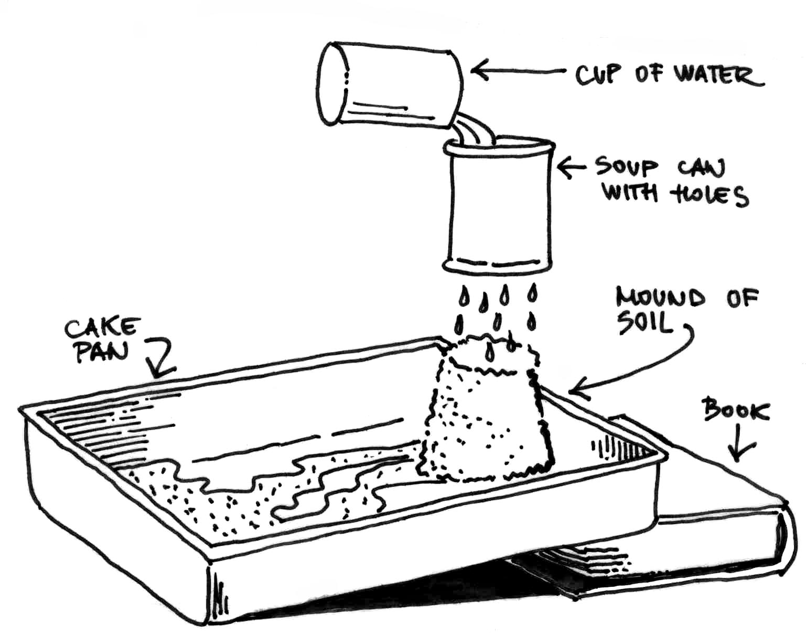
- Observe the amount of soil in the "lake" at the bottom of the pan.

Which one of the mounds produced the greatest amount of sediment? (The mound that was not covered with vegetative litter.)

What effect did the vegetative litter have on erosion? (It reduced the erosion by protecting the soil from direct impact of the rain.)

Discussion: Man-made soil erosion
Discuss with students what causes soil erosion and how humans influence it:
- What causes soil erosion? (Soil erosion can be caused by water, wind, ice or heat. But the most important cause of most soil erosion today is improper land-use, mainly caused by farming.)
- How can farming be the cause of soil erosion? (Because plants and trees that hold the soil together are cleared to grow crops. Sometimes, when the soil is left bare, and when it rains or is windy, the soil can easily be washed away.)
- How can soil erosion be prevented? (Grass, trees, bushes, shrubs, and even weeds help break the force of raindrops and hold the soil in place. Where cultivated crops are grown, plowing and planting on the contour, terraces, and grassed waterways to carry surplus water from the fields are some of the conservation measures that slow running water. Any kind of mulching protects the soil when it has no growing cover.)
- Can a fire in woods cause a landslide? (Vegetative cover of the ground can be completely destroyed because of a fire, which can cause soil erosion and a landslide.)
- What are other causes of soil erosion? (Overgrazing, that is when animals eat all the grass and leave the soil bare, or deforestation, that is when forests are cleared from the land, so that timber can be sold and land used for growing crops and farming.)
- How much soil erodes in the world every year by rain and wind? (23.000 million tones and 10 million hectares of forest trees are being lost, which exposes the soil to erosion.)
- How much time new soil needs to be formed? (It is a very slow process. It takes from 3.000 to 12.000 years to make a layer of soil that can be used by farmers.)

Lesson F5: COASTAL EROSION

Main idea: Coastal lands, which include cliffs and beaches, are constantly eroding. Over a period of time, coastlines change because of erosion and beach shifting. Sand washed away from one stretch of coast is deposited further up (or down) the coast. Coastal erosion is difficult to predict and almost impossible to stop. Waves are the primary energy source that causes coastal erosion. Most waves are created by winds blowing across the surface of the ocean. Large storms generate destructive ocean waves. Waves breaking at the base of cliffs can cause them to erode and collapse. When waves break at an angle to the shore, they can create longshore currents, which transport sediments along the coast. Sediments can be eroded from one location and deposited in another. Coastal erosion depends on the stability of shoreline sediments, the intensity and frequency of storm waves, and the exposure of coastal lands.

Goal: To help students understand coastal erosion caused by waves, which includes observation of how waves affect the movement of sand and erode cliffs on a coastline, observation of how coastal erosion can affect buildings constructed along the coast, and observation of differences in erosion caused by different size waves.

Concept: waves (storm, typhoon, tsunami), wind (currents, longshore current) → coastal erosion, sediment movement → cliffs, sandy beaches;
Introduction: What is coastal erosion?
Discuss with students about different types of beaches in connection to coastal erosion:
- What kind of beach do they know?
- How cliffs and sandy beaches are formed?
- Where does the sediment that forms a beach, or dune come from? (It can come from rivers, cliff erosion, waves, or currents that flow along the shore. Waves, currents, and storms can also remove or erode coastal sediments.)
- What is beach erosion? (Beach erosion is the loss of sand, due mostly to wave action and wind.)
Activity: Coastal erosion model
Materials: one large paint tray or large rectangular container at least 35 cm by 28 cm, 1 liter of moist sand, 0.6 liters of water, one 15cm long wavemaker (ruler or wooden board), paper and pencil, a metric ruler, three small pieces of wood (used to represent houses or buildings);
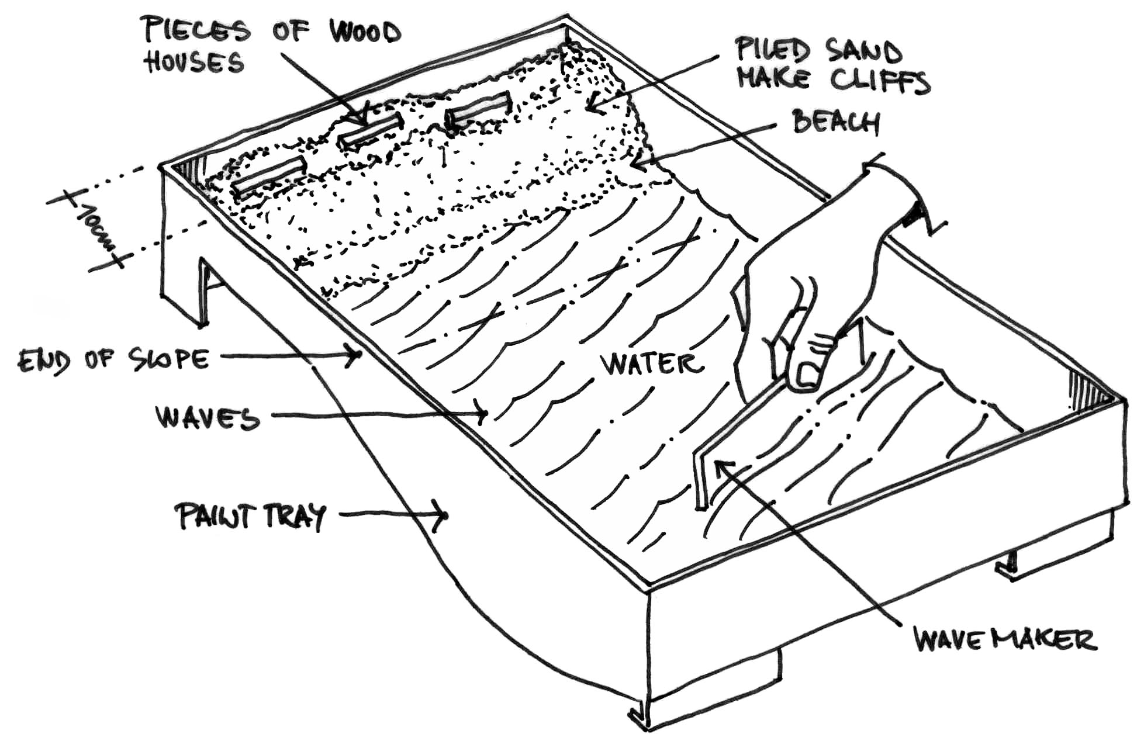

Explain students that they will explore coastal erosion using a simple model they will create:

Let them pour about one-half of the sand into the container, spreading it evenly over approximately three-fourths of the sloping part of the paint tray from the top edge down. This side of the container should then be elevated for a couple of cm. The sand represents a sandy beach. The open area of the paint tray or container will be filled with water, representing the ocean.

Add the remainder of the sand to the top of the container to form dunes or cliffs. These landforms should some cm high and should not extend more than 10 cm from the top of the tray or container.

Let students place the pieces of wood any place they choose in their model. The wood pieces represent houses or buildings.

Add approximately 2/3 liter of water to the bottom part of the pan where there is no sand.

Draw a diagram of the model, including the width of the beach, the width and the high of the cliffs or dunes, and the location of the houses or buildings.
- Exploring normal wave activity: Explain students that erosion has played a major role in changing our coasts.
- Ask the students to predict some effects of coastline erosion.

Have students create waves in the model-ocean using the wavemaker. They should hold the wavemaker horizontally and use a sharp, short, pushing motion, pushing the waves at one corner of the container, at an angle to the beach. This set of waves should be small, breaking on the beach below the cliffs or dunes. They should make approximately 60 waves.
- Explain the students that most waves are created by winds. The size of a wave depends upon the force of the wind, the length of time the wind blows, and the amount of open water over which the wind can blow. As waves get closer to shore, depths tend to become more shallow, causing waves to break. Storm systems, such as typhoon, and movement on the ocean floor usually caused by earthquakes (tsunami) can create waves up to 30 meters high. When such a wave reaches the coastline it can result in flooding, erosion, property damage, and loss of life.
- What causes the sediments to move along the coast? (longshore currents)
- In which direction the longshore current moves? (Along the beach at an acute angle to the waves.)

Observe the model and draw the second diagram of the beach, measuring the width of the beach and dunes or cliffs and recording the locations of their houses or buildings.

Compare "before-and-after" diagrams. Has there been any movement and deposition of sand along the beach?
- Was there any change in the shape of the beach and the dunes or cliffs?
- What happened to the houses or buildings? Are they safely located?

Exploring large storm or typhoons waves:

Have students make waves again. This time the waves should be large enough to touch the cliffs or dunes. These larger waves represent waves created from large storms or typhoons.

Students should make a third diagram of the coastal lands. Be sure that they measure the length and height of the cliffs and dunes on the diagram and the locations of the houses and buildings so that they can compare them to the first diagram.

Has there been any movement and deposition of sand along the beach?
- Was there any change in the shape of the beach and the dunes or cliffs?
- What happened to the houses or buildings? Are they safely located?
- Let the students to experiment with different waves. They should make waves that approach the coast under different angles. They should also make different shapes of the coast and experiment with that. For each experiment they should draw “before-and-after” diagrams of the coast and describes their observations.
- What happened to the coastal landscape and the houses and buildings students placed on it? Would you live in one of the houses at the location you chose on your model?
- Is it safe to build houses close to the seashore? When is it safe and when not? Why?
- Exploring the protection of a beach from erosion:
- Ask the students to think what might happen to a certain beach if it is not protected from erosion?
- Ask the students to remound the sand and cover the sand thoroughly with gravel.
- Have students create waves in the model-ocean using the wavemaker again and observe the effect of beach protection on coastal erosion. Tell the students that gravel, rocks, and boulders can be used to hold sand in place (to slow erosion).
- Ask the students to compare what happened to the sand with and without gravel.
- Tell the students that we can also build structures that protect beaches from erosion. Sometimes fence-like structures on the beach are effective. Sometimes we can build big barriers out in the water to take some of the force of the waves. We can even build wall-like structures from the beach out into the water to catch sand as it is being washed away from a stretch of coastline.

Discussion: Why beach erosion is a problem?
Discuss with students reasons why beach erosion can be a problem and how this problem can be solved:
- What can be the consequence of extensive beach erosion? (Extensive beach erosion can dramatically change the nature of the shoreline, and can even cause buildings to collapse.)
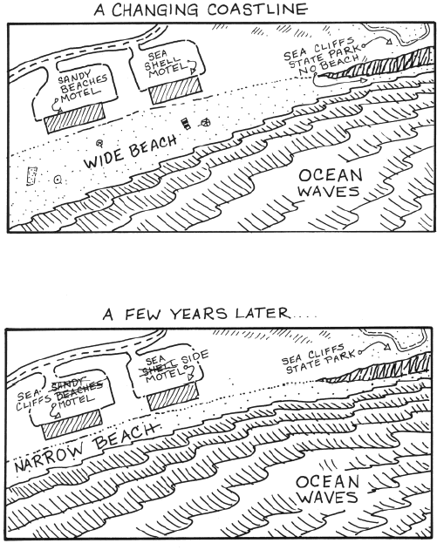
- Why beach erosion is a problem? (This is a problem chiefly because of human uses of beaches and adjacent lands. For example, beaches may erode tourist beachfront apartment homes and hotels built too close to the sea. Tourists are important to coastal communities and their economies.)
- Is it possible to protect a beach from extensive erosion? (We can take action to modify eroding beaches in a ‘soft’ way by supplying sand or in a ‘hard’ way by building hard barrier structures to lessen the force of waves and currents. Each way has its own advantages and disadvantgas, and both need deep rooted understanding of natural coastal processes. We can control development so that people do not build structures on places where erosion will damage them later on. And we can stimulate nursing and planting of mangroves and seagrasses that help anchor coastal areas and providing safety against flooding.)

